
AI-Based Airport Passenger Flow Prediction System for Efficient Resource Management

Project Report Submitted

To

Dr. D. Y. Patil Vidyapeeth, Centre For Online Learning, Pune

In Partial Fulfilment of the Requirement for the Award of the Degree of

Master of Business Administration

BY

Kale Divya Anil Sudha
ERP ID : 241114219
PRN : 2405020010233

Under the Guidance of

Professor External Company Vikas Kumar Atray
Dr. D. Y. Patil Vidyapeeth, Centre For Online Learning

Pimpri, Pune.

2024–2026

Declaration

I, the undersigned, hereby declare that the Project Report entitled
“AI-Based Airport Passenger Flow Prediction System for Efficient Resource Management”,
submitted by me to Dr. D. Y. Patil Vidyapeeth, Centre for Online Learning, Pimpri, Pune, in partial fulfilment of the requirements for the award of the degree of Master of Business Administration, is my original work.
The conclusions and findings presented in this report are based on the information and resources collected from reliable sources and compiled by me. This work has not been submitted to any other University or Institution for the award of any degree, diploma, or fellowship.
Place: Pune


[Kale Divya Anil Sudha]
Submission Date 25/05/2026

CERTIFICATE

This is to certify that the Project Report entitled “AI-Based Airport Passenger Prediction System for Efficient Management”, which is being submitted herewith for the award of Master of Business Administration MBA Online - July 2024 of Dr. D. Y. Patil Vidyapeeth, Centre for Online Learning, Pimpri, Pune, is the result of the original research work carried out by Dr./Mr./Ms. Kale Divya Anil Sudha having PRN 2405020010233 under my supervision.

To the best of my knowledge, the Project Report submitted by the student is in accordance with the guidelines prescribed by the Institute and the University.


External Company [Vikas Kumar Atray] Accepted Date 25/05/2026
Director DPU COL DPU COL [ Name]
Date: 10/06/2026

Organization Letter Head

CERTIFICATE

This is to certify that Divya Anil Kale has successfully completed an internship/training as part of the academic requirements for the MBA Program (Online) at our organization.
During this period, he/she was found to be sincere, diligent, and hardworking in carrying out the assigned tasks and responsibilities.
We wish him/her continued success in all future endeavours.


Authorized Signatory

[Vikas Kumar Atray]

Seal/Stamp [25/05/2026]

Note: This certificate is optional if not engaged in internship/training at any organization.

ACKNOWLEDGEMENTS

I take this opportunity as a privilege to express my deep sense of gratitude to Dr. D. Y. Patil Vidyapeeth, Centre for Online Learning, Pune, for providing me with the platform and resources to pursue my research.
I extend my sincere thanks to Dr. Safia Farooqui, Director, Dr. D. Y. Patil Vidyapeeth, Centre for Online Learning, Pimpri, Pune, for her continual support in fostering active learning and for her constant encouragement to achieve excellence. I also appreciate the dedicated efforts of the academic team, headed by Dr. Rajendra Takale, along with all the mentors, whose guidance and inspiration have greatly contributed to the completion of this research work.
I am deeply indebted to my research supervisor, External Company, Dr. D. Y. Patil Vidyapeeth, Centre for Online Learning, Pune. Without his/her invaluable guidance, constant motivation, and insightful suggestions, the completion of this project would not have been possible. I am sincerely grateful for the knowledge and research orientation imparted to me under his/her mentorship.
I also wish to extend my heartfelt thanks to all the teaching and non-teaching staff members of the Centre for Online Learning for their unwavering support and cooperation throughout this journey.
Finally, I am profoundly thankful to my family members, relatives, and friends for their encouragement, understanding, and support, which enabled me to complete this research successfully.

Place: Pune


Kale Divya Anil Sudha
Submission Date 25/05/2026

TABLE OF CONTENTS

Chapter no. | Content | Page no.
 | DECLARATION BY STUDENT
 | ACKNOWLEDGMENT
 | CERTIFICATE BY THE GUIDE
 | CERTIFICATE BY THE ORGANIZATION
 | TABLE OF CONTENTS
 | LIST OF ABBREVIATIONS
 | ABSTRACT | 4
1 | INTRODUCTION | 6
2 | OBJECTIVE, SCOPE, AND PURPOSE OF STUDY | 15
3 | REVIEW OF LITERATURE | 23
4 | RESEARCH METHODOLOGY | 34
5 | DATA COLLECTION AND ANALYSIS | 49
6 | FINDING AND INTERPRETATION | 56
7 | RECOMMENDATIONS AND CONCLUSIONS | 63
8 | FUTURE OUTLOOK OF AIRPORT PASSEBGER TRAFFIC | 70
9 | ANNEXURE – I | 71
10 | ANNEXURE – II | 75

LIST OF ABBREVIATIONS

Abbreviations | Descriptions
ACI | Airports Council International
AI | Artificial Intelligence
ARIMA | AutoRegressive Integrated Moving Average
CSV | Comma-Separated Values
DataSF | San Francisco Open Data Portal
EDA | Exploratory Data Analysis
IATA | International Air Transport Association
IT | Information Technology
KPI | Key Performance Indicator
LSTM | Long Short-Term Memory
MAE | Mean Absolute Error
MBA | Master of Business Administration
ML | Machine Learning
MSE | Mean Squared Error
NTPL | NTPL Digital Services Private Limited
Power BI | Microsoft Power Business Intelligence
Qollabb | Collaborative Digital Learning and Analytics Platform
RMSE | Root Mean Squared Error
SARIMA | Seasonal Auto Regressive Integrated Moving Average
SFO | San Francisco International Airport
Tableau | Data Visualization and Business Intelligence Tool
USA | United States of America
Wi-Fi | Wireless Fidelity
YOY | Year-over-Year
ACI | Airports Council International
AI | Artificial Intelligence
ARIMA | Auto Regressive Integrated Moving Average
CSV | Comma-Separated Values
DataSF | San Francisco Open Data Portal
EDA | Exploratory Data Analysis
IATA | International Air Transport Association
i.e. | That is (id est)
e.g. | For example (exempli gratia)
etc. | And so on (et cetera)
No. | Number
Sr. No. | Serial Number
% | Percentage
₹ | Indian Rupee

LIST OF FIGURES AND TABLES
Fig/Table.No | Title | Page.No
1.1 | Airport Passenger Forecasting Workflow | 7
2.1 | Comparison of Passenger Forecasting Techniques | 16
2.1 | Literature Review Summary | 17
3.1 | Airport traffic and passenger-flow forecasting | 23
3.2 | Data Cleaning Workflow | 25
3.3 | Monthly Passenger Traffic at SFO | 26
4.1 | SARIMA Forecasting of SFO Passenger Traffic | 37
4.2 | Future Passenger Forecast for SFO | 38
4.3 | Residual Error Analysis for SARIMA Model | 39
4.4 | Density Plot of Residuals for Forecasting Model | 39
4.5 | SFO Passenger Traffic Forecasting Results | 41
4.6 | Successful Execution of Streamlit-Based Airport Passenger Forecast Dashboard | 48
6.1 | Airport Passenger Forecasting and Resource Planning Workflow | 57
6.2 | Future Passenger Forecast Generated Using the SARIMA Model | 61
6.3 | Forecasted Passenger Traffic Trend for San Francisco International Airport (SFO) | 62
7.1 | Scenario-Based Airport Planning and Decision Support Framework | 63

ABSTRACT
“Study On AI-Based Airport Passenger Flow Prediction System for Efficient Resource Management”
By

[Divya Anil Kale]
MBA Sem IV [2026]

Project Supervisor: [Vikas Kumar Atray]
Specializations: [AI & ML]

Looking into how freely available numbers from San Francisco International Airport might predict traveler movement - helping staff make decisions backed by actual patterns. Copenhagen Optimization once shared basic steps online about guessing airport crowds, suggesting smart guesses let hubs assign check-in desks, screening lines, gate space better. Raw figures pulled straight from the city’s public database track flyers each month split by flight category and carrier stretching back several years. That pile of records works well when spotting repeating yearly shifts, steady shifts among carriers, slow overall rise in foot traffic through terminals.
This work focuses on three goals - understanding past passenger numbers at SFO, building a basic time-series forecast using regression methods, while showing how such predictions offer useful guidance for airport staff. After organizing and refining the raw information, initial exploration reveals patterns, recurring cycles through months, along with contrasts between local and overseas travel volumes. With those findings, a starting predictive method takes shape, checked against unseen portions of data by tracking mistakes via average deviation and percent-level inaccuracies. Even in simplicity guides its design, the approach still follows big shifts across seasons, delivering estimates reliable enough to help plan workforce needs and space usage weeks ahead. Closing thoughts suggest ways this organized path could grow - adapting stronger techniques or applying similar logic elsewhere, forming a steady link from traveler projections straight to operational choices.
One step beyond modeling, this effort builds a straightforward dashboard that links predicted traveler numbers to estimated requirements for check-in desks, screening paths, and boarding doors - making outcomes easier to grasp for those outside technical teams. While diving in, it touches on limits tied to data, like coarse grouping and missing live updates, then shifts toward how airfields might push forward using richer daily records and newer prediction tools shaped by recent studies. These layers do more than shift paperwork into number crunching - they quietly shape a working aid ready to guide choices within terminal control units.

Keywords: Airport passenger forecasting, Air Traffic Passenger Statistics, San Francisco International Airport (SFO), time-series regression, operational planning, resource allocation
AI-Based Airport Passenger Flow Prediction System for Efficient Resource Management
CHAPTER 1: INTRODUCTION

Busy hubs help communities grow by moving travelers, goods, trips between nations. Two full turns around the sun ago, flying got way more popular - better paychecks, curiosity about far places, deals crossing borders pulled numbers up. Crowds piling into spots like bag drop, scanner lines, passport checks, gate seats create wait snarls, lost flights, grumpy faces. Extra hands or open lounges when nobody shows? Money slips away quietly. Guessing who arrives, when exactly, via which path stays tricky yet essential. Planning ahead beats fixing things mid-rush every single time.
Lately, guessing how many travelers will move through an airport has become something every major hub pays attention to. Guidelines from global organizations plus reports from actual terminals suggest solid prediction tools help decide where to open desks, when to staff screening zones, and how big future shops should be. Take security lines and people switching planes - studies reveal knowing when crowds arrive means teams can adjust staffing, shorten queues, people heading toward missed connections get spotted earlier. Firms selling tech platforms along with advisory services now push systems using past movement records, live sensor inputs, algorithms trained to anticipate traffic down to each hour or sometimes every sixty seconds - a sign number crunching plays a bigger role than before inside air travel hubs.
Looking into how many people move through San Francisco International Airport means working with openly shared numbers from Data SF. That city site posts monthly tallies showing who flies where - split by airline, world zone, and kind of trip - stretching back years. Growth trends appear step by step across past reviews: travelers keep rising, slowly but surely. Summer brings surges. So do December holidays. These repeating highs open space for predicting what comes next using timeline methods. Being able to check each number freely helps others follow along without guessing. Public access keeps work clear, grounded, repeatable.
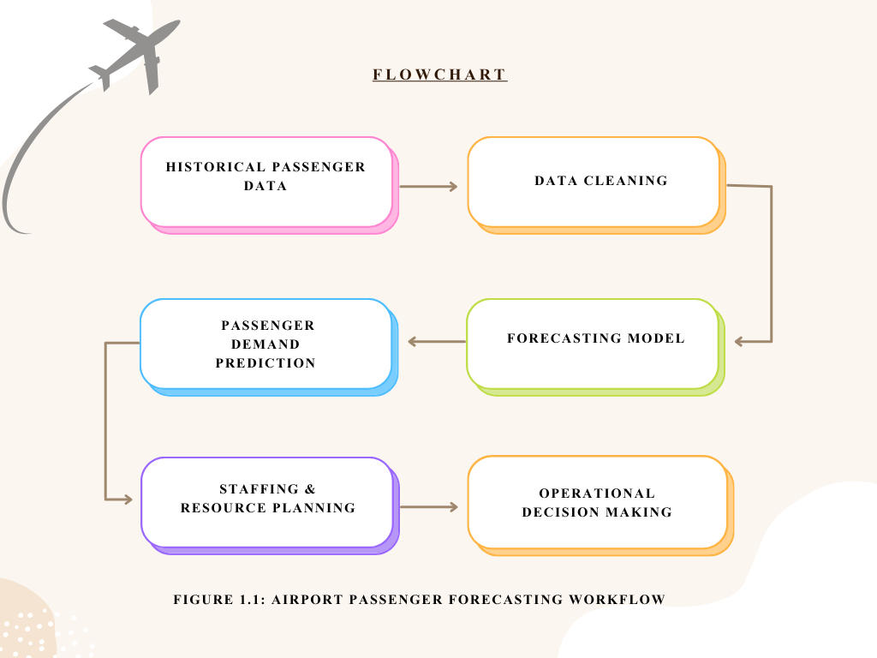
Figure 1.1: Airport Passenger Forecasting Workflow
Source: Prepared by the author.
Out there among real-world tools, one post from Copenhagen Optimization - called “Airport Passenger Forecasting 101” - shaped how this work took shape. That piece walks through how airfields rely on projections when arranging staff, check-in spots, and boarding zones. Instead of treating estimates as static number games, it shows them feeding into ongoing loops where teams tweak guesses after seeing what actually happens. What stands out? Pulling together bits from different places matters - past traveler counts, flight timetables, even shifts in visitor patterns abroad - all mixed to strengthen results. With that hands-on mindset guiding things here, the effort leans toward methods clear enough for planners to follow, while still holding up under scrutiny when choices about daily operations come due.
This research builds on ideas from time-series prediction and how organizations manage workflows. Looking back at past traveler numbers helps split patterns into steady changes, repeating cycles, slow shifts, alongside random bumps - each piece extended forward to guess what comes next. Studies examining air travel predictions test different tools, including basic equations, statistical models like ARIMA, even network-based learning systems that mimic brain activity; findings show intricate setups may predict better, yet straightforward ones still win trust due to clarity and less setup effort. Viewing terminals as lines of people awaiting service reveals how expected arrivals, processing speed, crew schedules shape key results - one might track typical wait duration or risk of overcrowding. Such links tie the work directly to classroom topics around handling customer flow and adjusting resource limits under pressure.
This research looks at passenger numbers at SFO through different lenses. From the start, its goal is to map out how those numbers have changed across years. Growth trends appear alongside repeating seasonal dips plus shifts tied to recessions or health crises. A closer look comes next - through a forecasting tool built on past data patterns. That model predicts monthly traffic using standard measures like average error size to check accuracy. Instead of stopping at predictions, it links them to real airport needs. Staffing levels and space demands follow from expected traveler counts, guided by established flow benchmarks. How these insights are shared matters just as much. Visual displays turn complex outputs into clearer messages for decision makers without technical backgrounds. In practice, this connects number work directly to daily operations.
Even though this report focuses on SFO, its methods aim to work at different airports too - places like India, where more people fly each year and new terminal space is being built fast. Open data plus clear modeling steps let universities and companies team up easily, giving students hands-on experience across every part of analytics: gathering numbers, fixing errors, building models, checking results, making sense of it all. Working alongside a tech-focused business using Qollabb shows learners real-world challenges tied to how industries now rely heavily on digital tools and insights pulled from data. From start to finish, the setup leads into a close look at predicting foot traffic in airports - a mix of theory, actual testing, and usefulness for daily management tasks.

  - Company Profile

Company Name: NTPL Digital Services Private Limited
Industry: Information Technology, Digital Transformation, Managed IT and Cloud Services
Legal Structure: Private Limited Company
Head Office: Noida, Uttar Pradesh, India (with registered corporate presence in Haryana)

1.2 About the Company
Start with managing tech systems, then move into running software tools smoothly. Infrastructure comes first, followed by handling how programs work day to day. Data flows in next, shaping decisions through analysis. New technologies enter later, woven into what already exists. Each piece connects without force, fitting around real needs.
A tech-focused firm, NTPL Digital helps businesses move through digital change using a full set of IT solutions. Built on expertise, it walks alongside companies aiming to upgrade their communication and data systems, boost how smoothly they run, while tapping into tools like cloud platforms, data analysis, and smart software. Staffed with accredited experts and field-specific talent, the group handles tasks from running servers and networks, refreshing older programs, giving tech advice, to overseeing ongoing service operations - serving clients at home and abroad.
What stands out about NTPL Digital is how it shapes solutions around each client instead of pushing standard packages. Because system failures can cost companies money and trust, steady performance sits at the core of their approach. Built-in safeguards, constant oversight, and regular checkups form part of their method behind the scenes. Industry benchmarks guide much of what they do, making sure technology supports business goals without disruption. Their way of working quietly follows patterns seen in strong corporate IT frameworks.
Sometimes NTPL Digital handles routine tech tasks, yet it also shapes big-picture plans like shifting systems to the cloud. Because of this blend, schools find value in partnering with them for hands-on learning. While some teams fix daily issues, others explore ways machines handle data faster. When workflows become automated, people gain time for deeper analysis. Since real-world problems appear often, learners tackle challenges tied to speed, stability, and smart choices backed by numbers. Though not every project moves at once, progress builds through steady effort. Where older methods fade, new approaches take root quietly. As needs shift, so does support - always present but rarely loud.
Lately, tech service firms have been turning attention toward new areas - so too has NTPL Digital, especially around tools powered by artificial intelligence and systems that learn from data patterns. Clients now more than ever need ways to turn raw information into forecasts, say about how shoppers act, where risks might pop up in daily operations, or how best to assign staff and supplies. Working alongside learners via collaboration hubs like Qollabb lets the company tackle real-world analysis tasks similar to those it handles for paying customers; at the same time, students gain guidance plus a peek into professional workflows. For this reason, within these pages, NTPL Digital sets the backdrop for the work on predicting air travel numbers, showing its push toward smart, data-backed digital services along with backing hands-on training efforts.

  - Role of Artificial Intelligence in Airport Operations
These days, smart computer systems play a big role in how airports run. Running an airport now goes beyond old methods like hand-made schedules or basic programs. Across the globe, automated tools shaped by learning algorithms are stepping into daily operations - streamlining workflows while cutting down lines at checkpoints. By handling huge volumes of past and live information swiftly, such technology supports staff in choosing more effective actions. What used to take hours to analyze gets sorted in moments, shifting how teams respond to changing conditions.
Predicting how many people move through an airport is a key way AI gets used. Because it studies old data on travelers, along with arrival and departure patterns, climate shifts, plus peaks tied to holidays or seasons, forecasts turn sharper. When numbers point to busier hours, staff adjust: more checkpoints open, extra desks appear at check-in, border stations fill up, gate access expands. Decisions about these resources rely heavily on what the models suggest will happen later. Management watches these insights closely before setting daily operations.
Something else AI helps with is handling lines more efficiently. When people gather too long at security or passport checks, things slow down. Cameras watch how folks move through terminals. Sensors pick up where paths get tight. Past behavior gives clues about future crowding. Predictions come together using that data. Extra desks appear when needed because of those forecasts. Travelers then flow into spots with fewer bodies nearby. This keeps movement steady without sudden jams.
Starting at the gate, some hubs apply artificial intelligence to match faces and confirm identities. Instead of handing over a passport, travelers move through steps like check-in or bag drop using just their face in several global terminals. This cuts down wait periods, yet tightens safety alongside quicker movement. Places including Dubai's main airport, Singapore’s Changi, and Heathrow in London run these smart identity checks to handle crowds better.
Most issues during operations fade when smart tech manages suitcases. Luggage gets spotted instantly thanks to sensors working alongside learning software. Mistakes in where bags should go show up fast, cutting down delays and losses. Equipment watches itself in certain terminals, spotting weak spots before things stop running.
Out of nowhere, artificial intelligence began reshaping how safety teams do their work. Instead of relying only on eyes and screens, cameras now spot odd behavior - like someone leaving a bag behind - without being told. When something feels off, alerts pop up so people know where to look. Efficiency sneaks in because machines handle scanning while humans step in when needed.
Robots that talk are showing up more often inside airport halls. Air carriers and travel hubs put these smart helpers to work handling traveler queries - flight times, where gates sit, rules about luggage, how to move through terminals. When one of these digital tools takes a question, human agents get some breathing room. Help comes fast, no waiting, even during quiet hours when few workers walk the floors.
Smart tech is spreading through airports, turning them into sharper transit centers. Problems once handled too late now get flagged early thanks to forecast tools guiding decisions ahead of time. This effort taps passenger prediction methods, part of a wider shift where numbers and artificial intelligence shape how runways and terminals operate.

1.4 Importance of Passenger Forecasting in Modern Airports
Figuring out how many people will pass through helps run an airport well - operations shift based on traveler numbers at various times. When crowds swell, space, workers, and systems need to keep up. Guessing wrong means chaos: too few gates open, lines pile up, things stall. Mistakes like that leave travelers frustrated, waiting longer than needed. Planning ahead avoids messes before they start.
Most times, knowing how many travelers will arrive shapes who works where. Airports need people in roles like checking bags, guiding passengers through checkpoints, managing boarding queues, overseeing border checks, assisting guests, operating ticket counters, and supporting planes on the tarmac. When crowds shift - because of weather, public breaks, big games, or time of year - it changes what each role must handle. Predictions let leaders picture coming loads weeks ahead. Staffing plans then match real needs instead of guesses.
Most travelers hate standing around too long. Terminals, gate zones, screening spots, luggage belts, parking lots - each hits max load fast. When holidays hit, crowds swell fast, lines stretch out, everything slows down. Smart estimates let managers spread things out, people and gear alike. Space gets used better when leaders see busy spells coming.
Most of the money airports collect comes from people passing through. When more travelers arrive, income grows - not just from airlines but also parking lots, stores inside terminals, eateries, and various onboard services. Looking ahead at expected traveler numbers helps managers map out budgets with better accuracy. Planning years in advance shapes choices about building bigger halls, adding runways, or updating digital systems. Financial foresight ties directly into how facilities prepare for what’s next.
Most folks just want a stress-free journey through the airport. When lines drag on, people notice - especially at security or check-in counters. Smarter predictions mean staff show up where they’re needed most. Instead of chaos near gates when flights back up, space opens naturally. Crowds thin out if arrivals are staggered by design. Service stays steady, whether it is quiet or packed. What feels like luck? It usually comes from looking ahead.
After the pandemic hit, guessing what comes next mattered more than ever. Sudden drops in international flights caught everyone off guard. Old ways of predicting traffic by looking at past trends stopped working well since how people traveled shifted hard. Now airports lean into planning that imagines different futures just to stay ready. What happens next stays unclear, so thinking ahead means playing out many versions of tomorrow.
Weather patterns shift, yet predictions help shape smarter airport choices. Running an airport takes lots of power, while daily traffic adds strain on surroundings. Because forecasts exist, facilities adjust how they use materials and lower wasted electricity. With those insights, growth projects follow greener paths instead of old habits.
Guessing how many travelers will pass through helps airports run smoothly, stay on budget, shape buildings right, plus keep people happy. Knowing what traffic to expect down the line now matters deeply inside today’s airport control setups.

1.5 Challenges in Airport Resource Management
Every second counts when juggling people, planes, staff, and tech that never stops moving. Though chaos seems close, order holds through careful steps taken minute by minute. When schedules shift without warning, responses adapt just as fast. Movement flows only if each piece fits precisely during sudden changes. Behind steady progress lies constant adjustment, silent but sharp.
Busy times at airports come and go without warning. Seasonal shifts, holidays, even weekend patterns pull travelers in waves. Stormy skies or a shaky economy can shrink crowds fast. A sudden world event might empty terminals overnight. Crowds pack gates one week, then vanish the next. Staffing feels stretched thin when lines grow long. Quiet days leave workers idle, spaces unused. Matching team size to traveler flow turns into constant guesswork. Infrastructure sits ready but waits too long between surges.
Long lines at security checks cause big headaches for airport staff. Delays here matter more than most places since they shape how travelers feel and mess up plane departures. When peak times hit, having just a few lanes running leads to snaking waits almost instantly. Yet keeping extra lanes active when crowds are thin burns money without reason.
Figuring out where planes park isn’t easy - airports juggle arrivals and departures nonstop. When a flight runs late, schedules shift, mechanics step in, or storms roll through, gates get reshuffled on the fly. Mess up the plan, and flights wait around while travelers wander lost.
Besides passenger flow, moving luggage brings extra challenges. Thousands of suitcases move through major hubs each hour. When machines break down, tags misroute, or workers are missing, delays spread fast. Smooth bag transport depends on timing - airlines, ground crews, and digital networks must stay in step.
Figuring out how many workers an airport needs can be tricky. When travelers come in waves, schedules must shift just as fast. Too few people on duty means long lines, slow help, fewer smiles. Too many staff sitting idle burns through budgets. Each team - security, cleaning crews, gate helpers, luggage teams, runway guides - needs its own balance. Demand spikes without warning. Predicting it right keeps things smooth. Getting it wrong shows up fast in stress or spending.
Storms hit. Machines fail. Workers walk out. Danger shows up at checkpoints. A virus spreads worldwide - airports feel every shock instantly. When things go sideways, routines break fast. Quick thinking becomes necessary just to keep moving. Plans shift on the fly because waiting isn’t an option.
Weather shifts, flight delays, crowd surges - airports face constant change. Because of this, guessing what comes next has grown harder over time. Machines that learn from past patterns now step in where guesses used to rule. These tools study old travel numbers to spot trends others might miss. When schedules shift suddenly, preparations based on data hold up better. Staffing levels adjust before crowds build, not after. Passenger lines move faster when timing aligns with real behavior. Even surprises feel less disruptive if plans expect some chaos. Planning ahead with smart models makes daily uncertainty easier to handle

Chapter 2: Objective, Scope, and Purpose of Study

2.1 Objective

This project aims to build a working method for predicting traveler numbers at San Francisco International Airport with public data and time-based models, while also making sense of findings for day-to-day operations. Starting from that main aim, the research follows multiple linked paths - exploring patterns in past data, creating forecast tools, then viewing outcomes through the lens of airport management needs.
Looking back at how travelers moved through SFO begins with data pulled from the city’s open records site. Monthly numbers reveal trends that stretch across years, showing peaks and drops shaped by time of year. Unexpected shifts pop up when outside forces hit - recessions, health emergencies, things like that. Peering into these changes helps spot where normal breaks down and new rhythms begin. Growth isn’t steady; it stutters, jumps, then sometimes stalls without warning. Each twist in the data ties to something real happening beyond airport walls. Patterns emerge only after sifting through months layered with context. This groundwork becomes what later comparisons lean on. Seeing what already happened shapes how forecasts are weighed later. Past flows act as reference - not prediction - but a mirror held up to movement over time.
Next comes building a method to predict how many travelers will pass through each month, looking ahead across a set timeframe. Instead of black-box systems, the work follows common airport trends by choosing clear statistical models that break patterns into long-term movement plus repeating cycles. Where it makes sense, newer techniques get tested alongside these basics. To judge what works, typical measures like average size of errors and average percent differences guide decisions - making sure claims about accuracy rest on numbers, not guesses.
To reach the third goal, numbers get turned into practical advice for those who plan airport operations. What matters most isn’t just predicting traffic but shaping choices on crew size, wait lines, because official reports stress usefulness in real planning. For example, expected traveler counts link to needed check-in desks, since methods drawn from flow studies help estimate such needs. These links between people and space aren’t exact though, given they shift based on location, so results stay rough guides shaped by setting. Each projection adjusts using standard models meant for movement and resource design, showing what might be required under different loads.
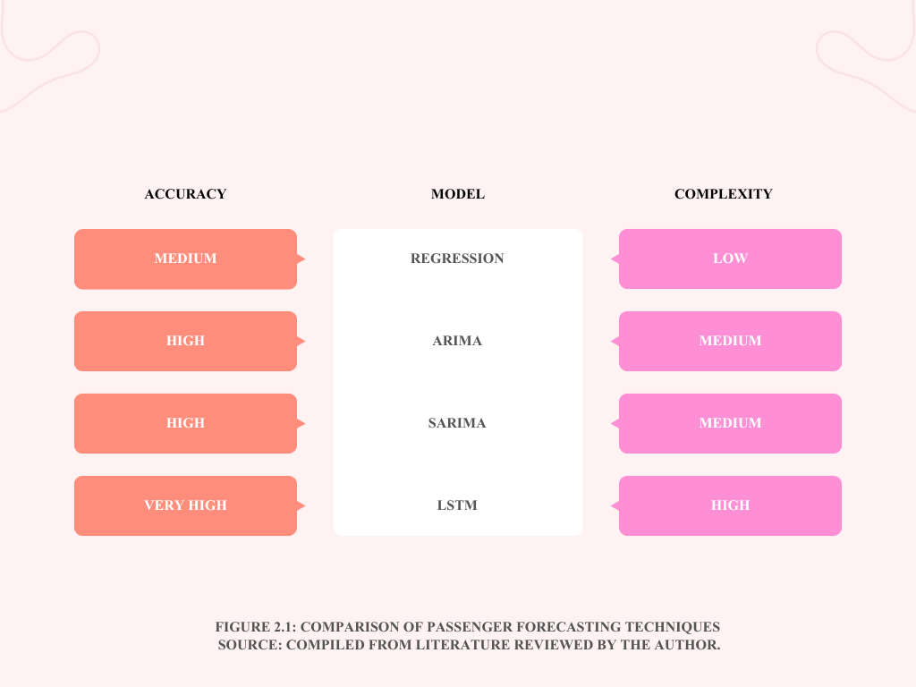

Figure 2.1: Comparison of Passenger Forecasting Techniques
Source: Compiled from literature reviewed by the author.

Visuals and a basic dashboard will show the findings, linking open data with forecast models in a hands-on support system. Built to fit how NTPL Digital Services operates - solving live client challenges through tech and data work. Clear presentation matters just as much as the numbers when turning analysis into something people actually use.
Wrapping up, goal number five focuses on education by offering students a clear path to practice every stage of analytics. Starting with gathering data, then shaping it, building models, checking results, finishing with how to share findings - all centered around an actual challenge in airline operations. Instead of just theory, they get to work like professionals would. Industry leaders have been asking for exactly this kind of training. People who step into jobs already knowing how real data behaves under pressure. Learning by doing becomes the core - not just memorizing steps but living them.
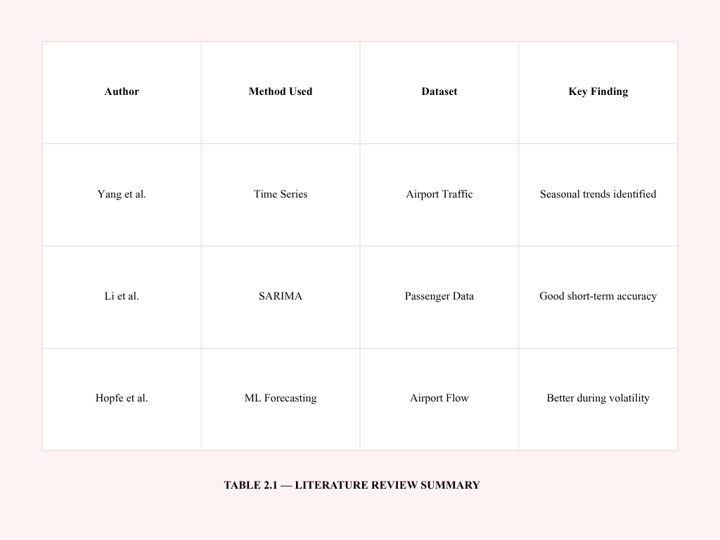
Table 2.1 : Literature Review Summary
Source: Compiled from literature reviewed by the author.

2.2 Scope of the Study

This study narrows its focus on purpose, aiming to dig deeper despite limits in time and available information. Although the data covers multiple details like airlines, regions, and terminals at San Francisco International Airport, only certain parts are used here. Instead of examining every single flight path or carrier separately, attention turns toward broader patterns. Monthly overall numbers guide much of the work. Some splits - like trips within the country compared to those crossing borders - also shape how things unfold. Information comes strictly from the Air Traffic Passenger Statistics set. Depth matters more than width, given what's possible. Choices around scale help keep findings clear under real-world boundaries.
Looking at how far back the data goes, the analysis includes every year that has reliable records, which helps spot slow shifts across seasons plus sudden changes seen when the pandemic hit and what followed after. Predictions stretch forward enough to help with practical decisions, think two or three years out, but skip distant blueprints or instant adjustments needing split-second updates.
Starting off, the work leans heavily on past traveler numbers through single-variable time methods. Other studies bring up broader economic factors - like costs or flight supply - but those details are hard to find consistently for SFO. Some advanced systems, like neural networks, do well predicting checkpoint crowds quickly, yet they need fine-grained records and heavy computing power. Because of limited access and practical needs, this effort sticks to simpler models built from public sources and common software. Later versions might dig into complex options when conditions allow.
Even though the study looks at real-world conditions, its reach has clear limits. It skips full-scale modeling of terminal activity along with step-by-step queuing analysis through every phase. Rather than tracking each movement, it leans on broad passenger projections to shape rough estimates - like hourly volumes paired with general crew levels - using basic rules and standard benchmarks pulled from public sources. These outcomes work better as sample ideas showing possible applications of forecast data instead of fixed blueprints meant for SFO or similar hubs.
Spread out but locked on SFO, the idea in these figures reaches beyond what the stats reveal. Openness makes this work not just in busy centers, still in quiet spots too - think small airstrips managing packed schedules with little money. When funds run short, entry opens up; plain layouts with shared details bring in more people. Schools leading teams, local fields, groups lacking strong tech help - any might take part of this system. It starts at a single point, then moves quietly elsewhere by skipping what lies underneath. Openness keeps things moving, even when the way forward feels far off. What opens a door also lets you step through it. The path twists, yet that chance to enter stays put.
2.3 Purpose of the Study

Out of chaos comes clarity - live traffic feeds shape predictions meant to sharpen how hubs operate, showing plain numbers still hold weight when deciding what happens next. Most areas rely on old-style sheets or gut feelings to estimate busy times, yet those crumble once surprises hit or pressure builds. At its core lies a method built from actual records, unfolding piece by piece. Others might reshape it quietly, letting it slide into new settings without fuss.
Later on, figuring out how many travelers will show up is like squinting through mist with only dim light. Because global economies grow, flight traffic creeps higher, pressing tarmacs past comfort while counting costs and emissions tightly. Airport leaders use predictions to judge lounge expansions, gate adjustments, or whether big-ticket improvements make sense down the line. When disruptions strike or bounce-backs crawl, systems that map movement let managers hold things together without panic. Seeing the flow clearly makes steady operation possible, even under strain. Learning meets real work here. Through partnerships with NTPL Digital Services and the Qollabb platform, schools team up with tech firms to tackle actual data tasks from daily operations. Instead of relying only on theory, students dive into messy information pulled directly from live processes - they pick methods, test reliability, explain findings plainly to people who do not code or analyze numbers. Meanwhile, NTPL gains insight into how forecasting tools and visual reports could grow into finished offerings for transport networks or city projects. While learners sharpen abilities by doing, the company tests new solutions where they truly matter. What unfolds is practice shaping progress, one project at a time. Here, what you do matters more than numbers on a page, so practice shapes precision quietly. What began at a desk now moves into view - people notice, question, judge.
Ponder this one for a while - the goal here is making sense of how numbers guide flying’s comeback after the pandemic. Forecasting wasn’t always messy; once it was just math, but lately it’s about holding steady amid unknowns, spotting faint signs in restless times since the world shut down. Look at SFO's travel records through smart software and you see habits cracked wide open mid-stride, pushing analysts to rethink rigid models. When everything shifts before dawn, yesterday’s blueprint crumbles. Out of quiet thought, insight often appears - shaped more by feel than formulas. Not numbers but context gives it weight. A turn in direction matters as much as the path taken. Knowing when blends with knowing what. Shifts happen where awareness meets moment. Readiness slips in beside learning. Timing holds space between facts.

2.4 Significance of the Study
This research matters not just to scholars but also to those running airports, since decisions now rely more heavily on data. With travelers increasing across the world, air hubs must handle rising demands without compromising security or punctuality - comfort of passengers hinges on smoother processes too. Because of this shift, predicting how people move through terminals isn’t optional anymore - it’s built into how today's airports operate.
Looking at it through a scholar's lens, this work sheds light on ways open-access data fits into hands-on analytics tasks. While many prediction papers lean on private sector figures - often locked behind paywalls or permissions - this one takes another path. Instead, it builds useful forecast systems from freely shared records like those in the DataSF passenger traffic logs. By doing so, it gives teachers and learners a working example of how stats, trend modeling, ML methods, and logistics thinking come together. Real transport challenges become easier to explore when the raw material isn’t hidden away. What emerges is a clearer route for classrooms to tackle actual issues without relying on hard-to-get information.
What makes this study stand out is its bridge between forecast techniques and real-world choices. Often, prediction tools in academic work stay locked in theory, never touching actual control processes. Here though, the spotlight falls on how crowd estimates shape crew scheduling, safety prep, desk workflows, or boarding zone handling. Seeing forecasts through an operator’s eyes lifts their value in daily terminal routines.
One key part of this research looks at how smart software is changing travel hubs. Across the globe, flying stations now use learning machines to handle people flow, guess busy times, because it helps daily work run smoother. What this effort shows matches what’s happening in the field - number crunching tools help air terminals do better, especially when they stay clear and straightforward in design.
One more thing the study points out is how open-data setups matter. When data sits out in the public, it clears up who knows what, brings people together, yet pushes new ideas forward - letting scientists, learners, institutions test issues through common records. Checks get stronger too since others can retrace steps on their own, mainly due to freely shared results.
What stands out about the project ties into groups like NTPL Digital Services Private Limited, known for pushing digital change along with data-driven answers. Forecasting ideas link up here through real-world challenges faced in business settings. This effort shows collaboration between schools and tech firms actually working where classroom theory meets hands-on practice.
Lately, thinking about air travel has changed because of what happened after the pandemic. When COVID hit, it showed just how shaky airport operations could get when things shift fast. Old ways of predicting traffic, built only on steady past numbers, did not hold up well once chaos arrived. Because of this, many hubs now lean toward models that bend instead of break when surprises come. Looking closely at traveler trends during calm times and turbulent ones alike helps meet that demand in a quiet but meaningful way.

2.5 Expected Outcomes of the Study
One goal stands out here. This work should produce a clear method for predicting traveler numbers at San Francisco’s airport, drawing only on public information. Instead of guessing, it uses old passenger counts, then applies pattern-based math models over time. The result? Monthly estimates that hold up well enough to help guide daily logistics and staffing choices. Behind every number lies months of past movement, shaped into something useful. Planning gets easier when what comes next isn’t completely unknown.
Over time, traffic behaviors in the SFO data should become clearer. By exploring the numbers, slow increases may show up alongside shifts tied to seasons or odd events that change how passengers move. These insights might help shape future predictions and how operations are understood later on.
One likely result is a tool built to predict how many travelers will come later on - getting it fairly close. Season-based techniques like SARIMA or smooth trend trackers should pick up regular shifts seen each month when looking back at old numbers. Measures such as average error size, squared differences, and percent deviations may show results steady enough for decisions months ahead.
One goal is pulling useful operations clues out of predicted traveler counts. Rather than stopping at number crunching, the effort looks ahead - connecting future passenger volume to team scheduling, airport desk setups, screening line shifts, even where flights park. Seeing those links turns into a main result from the analysis.
Most likely, there will be dashboards built using visuals instead of just numbers. These graphics should clarify patterns like spikes during certain seasons or shifts over time. People who do not work with data every day might find it simpler to grasp what comes next. Teams handling daily tasks could stay more aligned with leadership thanks to shared views. Charts may act as a bridge when talking across departments.
One aim of the study is showing how open-data analytics can support learning. From start to finish, participants work through each phase - gathering information, preparing it, building models, checking results, then sharing findings visually. Doing all these steps builds familiarity with actual job tasks. Students gain skills that match what employers look for in data and artificial intelligence roles.
Looking ahead, the work aims to show why using artificial intelligence for predictions matters more each day at airports. Though the techniques tested here are basic, they reveal ways data forecasts might make travel systems sharper and daily workflows smoother.
One last thing - the study aims to spot what's missing, along with paths forward. Real-time predictions might come up as a next step. External economic factors could play a bigger role down the line. Machine learning approaches may shift how forecasts are built. Hourly movement of passengers might draw more attention later on. Each piece opens room for deeper work ahead.

Chapter 3: Review Of Literature

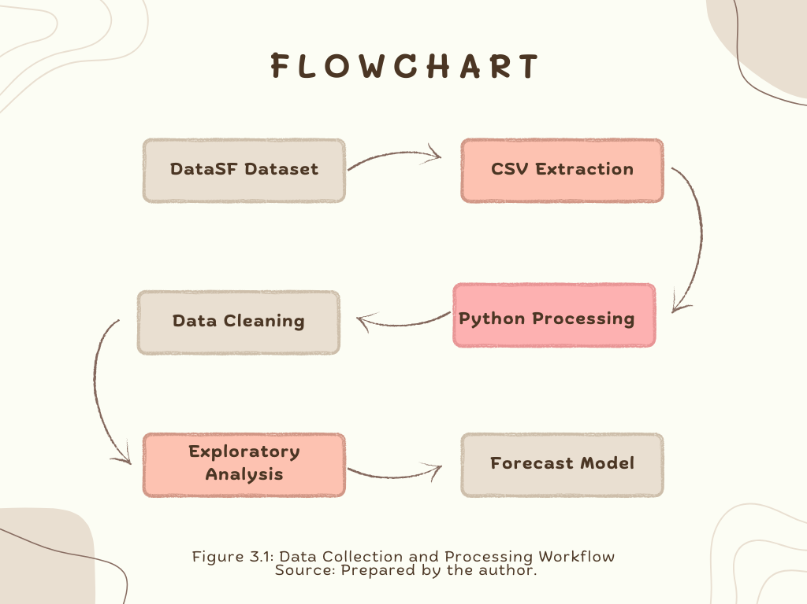
Many studies look at predicting airport travel numbers, movement of people through buildings, how spaces are used, plus ways math tools guide staff and space choices. Work from academics, groups in aviation, companies giving advice built methods tested in real cases showing prediction styles aid layout plans, spread supplies wisely, reduce surprises amid shifting conditions. Here we go over past work tied closely to this task zeroing in on three areas: ways to guess traveler counts and paths indoors, types of forecast systems picked and why one fits better than another, how projections shape daily moves and long-term goals for air hubs. Open access info plays a part too - like stats shared freely by San Francisco's main terminal - helping others check results, repeat findings clearly without barriers.Identifying high-demand agricultural products for export.

3.1 Airport traffic and passenger-flow forecasting
Source: Compiled from literature reviewed by the author.

3.1 Airport traffic and passenger‑flow forecasting

Looking back, early efforts in flight travel prediction focused on guessing how many people would fly to or from certain areas, mostly to help plan big construction projects years ahead. Reports by transportation research groups showed ways to mix past traveler numbers, broad economic trends, and airline industry factors using math-based models, aiming to project traffic levels decades into the future - often tied to plans for adding runways or enlarging terminals. Such analyses usually broke down forecasting into stages: starting with clear goals, then gathering information and picking suitable methods, finishing with testing outcomes under various what-if situations and checking results against key moments in prior data. What mattered most was keeping different parts of the projections in sync - like local flights compared to overseas ones, or trips for work contrasted with those for vacation - as well as making sure estimated travelers matched expected plane arrivals and departures within physical limits. From beginning to end, balance shaped each step.. Now airports handle more connecting flights. Because of this, people started looking closely at how travelers move inside terminals - especially near security lines and walkways between gates. Instead of smooth progress, mismatches between expected numbers and real crowds often slow things down. Such delays risk tight layovers plus on-time performance across schedules. So experts built tools aimed at narrow parts of terminal operations. For example, predicting how many transferring passengers reach screening zones every few minutes. They pull live flight updates along with past route choices to make estimates. What stands out is the value of frequent data feeds. Even minor gains in prediction quality tend to shrink wait times and lost connections noticeably.
Lately, some studies tackled predicting travel numbers when surprises hit - like outbreaks or big interruptions. When things get shaky, old methods built on stable past data tend to miss the mark, experts now see. Instead of sticking to fixed formulas, new approaches shift on the fly, using live updates and what-if setups. These updated systems adjust as conditions evolve, catching swings in traveler behavior more closely. Post-crisis reviews from airport groups point out similar moves: forecasts now include varied bounce-back paths. Gone is the habit of assuming tomorrow's travel will just follow yesterday's climb.
Most days, staff schedules hinge on predicting how many people will show up. When passenger numbers are expected to rise, more security lines open. Instead of guessing, some hubs rely on past data to set shifts. One airport might assign ten agents per thousand travelers each hour. Because every terminal works differently, these averages need tweaks now and then. Real world examples reveal a pattern - better predictions mean fewer last minute call‑ins. Systems that link arrival estimates with crew assignments tend to run tighter shifts. Overtime drops when managers know what volume to expect. Sudden spikes still happen, yet prep based on trends helps absorb them. Smooth flow through checkpoints often traces back to one thing - a forecast made earlier that week.
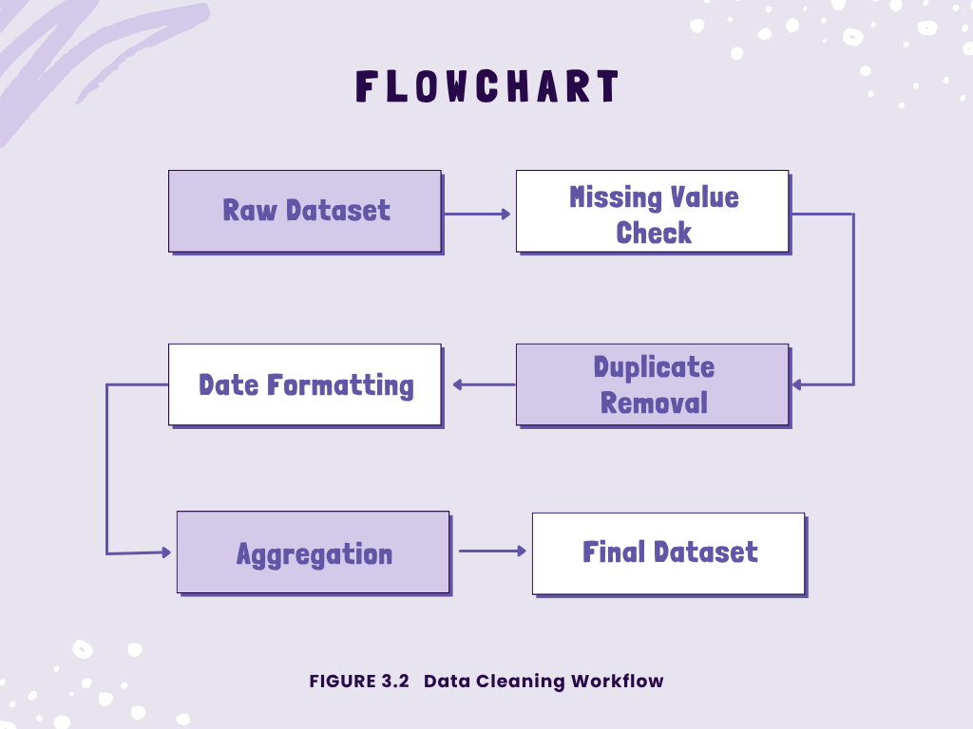
FIGURE 3.2 : Data Cleaning Workflow
Source: Compiled from literature reviewed by the author.

Lately, voices like ACI and similar groups stress a new need - forecasts should back up stability and handle risks, not only guess typical traffic levels. Updates on travel trends now come out faster, while varied scenarios test outcomes tied to uneven rebounds, shifts in how people move around, or rules like safety checks at transit points. One result? Models might lean toward simpler designs; they adapt quickly, make sense fast, even if the world shifts overnight. Heavyweight systems, packed with layers, could fall behind simply because they resist quick tweaks.
3.2 Use of SFO passenger statistics and open data
Most work on predicting airport travel now leans heavily on freely available information. Take the passenger numbers from San Francisco Airport, shared through DataSF - that one keeps showing up in classroom exercises and analysis papers alike. Month by month, it tracks who flies in and out, broken down by carrier and where they come from, plus details about gates and buildings people move through. Stretching back years, with fresh entries added often, this record gives teachers and analysts a way to show how trends shift across time, how visuals tell stories, even how something like a global health crisis alters movement patterns at hubs. Few records last that long, stay current, while offering enough depth for real insight.
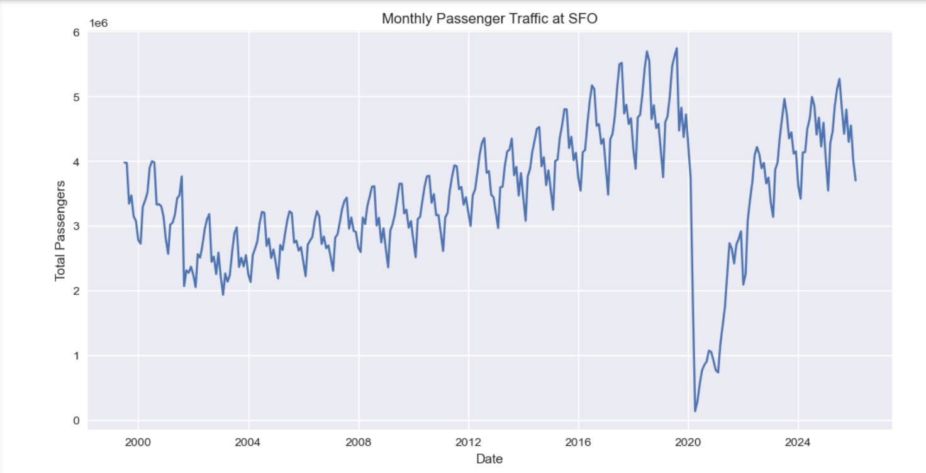

FIGURE 3.3 : Monthly Passenger Traffic at SFO
Source: Compiled from literature reviewed by the author.

Step one often involves loading the data through scripts shown in web guides, while public code libraries offer tools for handling the SFO numbers. Seasonal patterns emerge when applying decomposition methods, whereas forecast attempts rely on smoothing techniques or ARIMA setups found in sample workflows. Long-term shifts and repeating cycles appear clearly once visuals are generated, though their shape changes depending on the method used. A few research efforts zero in on how travel demand at SFO collapsed during 2020, because lockdowns reshaped movement almost overnight. Recovery began slowly, yet it never simply reversed the drop - instead, new habits took hold over time. Models built before everything changed tend to misjudge the pace of rebound unless they account for these deep interruptions. Ignoring such breakpoints leads to forecasts that run too far ahead of reality, mainly due to outdated assumptions lingering in the structure.
Most studies using SFO information stick to lectures and written summaries. Instead of testing ideas in real settings, they group patterns and make broad guesses. Rarely do those predictions link to actual decisions - where people are assigned, how equipment moves. Almost never is that knowledge shaped for airport supervisors unfamiliar with digital tools. Here’s space to stretch when guesses meet clear steps along with pictures. Every part built only from open details and programs available to all.

3.3 Research gaps and positioning of the present study
Earlier work misses pieces this study tries to complete. Small airfields often do not have what it takes for high-end prediction tools since they depend on scarce information along with heavy setup demands. Beyond that, papers looking at one-strip operations typically end with charts or basic projections instead of linking findings to real daily duties at terminals. Open approaches matter just as much as understanding bounce-backs following worldwide medical emergencies, yet hardly any research weaves these two threads together.
Oddly enough, this method covers a silent hole in studies while staying low-key. From common starting points, estimating how many people pass through SFO gets easier - using just open-source info. It slips into existing airport routines without pressure because precision beats fancy setups. Lately, experts stress clear results, which is precisely what this work quietly targets. Slow thinking kicks off every quick result. Where numbers point, interest follows in class. Fancy tools aren’t needed for it to move quickly. While NTPL Digital Services runs wide, this fits like a quiet guest. As efforts like Qollabb rise, schools lift without warning.

3.4 AI and Machine Learning in Passenger Forecasting
These days, computers that learn on their own play a bigger role in predicting travel trends, thanks to their knack for sorting through massive datasets while spotting hidden links without help. At airports, smart software guesses how many people will show up, warns about crowded areas, adjusts worker schedules, and keeps things running smoother behind the scenes.
Older ways of predicting numbers, like linear regression or ARIMA, mostly look at past data patterns. When those patterns stay steady, they work well enough. Yet passenger counts at airports shift due to layers of causes - holidays bring peaks, economies affect spending, flight plans change without warning. Tourist waves rise and fall, storms delay flights, pandemics halt travel entirely. Unlike older tools, machine learning handles tangled influences better because it learns complex links hidden in messy real-world data.
Most folks lean on linear regression when they need to predict things. Math formulas link time with how many passengers show up. It's straightforward, makes sense at a glance, takes little power to run. Yet gets tripped up by sharp changes or repeating patterns in travel numbers.
Starting off, ARIMA along with its variant SARIMA shows up a lot when predicting numbers over time. That happens since these methods handle patterns like upward trends, repeating seasons, and past values influencing future ones. When it comes to guessing how many travelers pass through airports each month, SARIMA stands out - those peaks every summer or holiday period? It sees them clearly. People stick with such tools even now, mainly due to their clarity in logic and lighter demand on computing resources compared to heavy-duty learning algorithms.
Some smarter ways to do machine learning are Random Forest, XGBoost, besides Neural Networks. Instead of one tree, Random Forest uses many decision trees together so predictions get better and overfitting drops. Nonlinear patterns plus how variables mix can show up clearly in these setups. With XGBoost, results climb higher because it brings boosting along with gradient tricks into play.
Though built from code, artificial neural networks pick up habits much like our minds do. Patterns deep inside massive piles of information become visible through their eyes. A special kind known as Long Short-Term Memory stands out when guessing what comes next. Because it holds onto distant links across time, it fits perfectly with sequences. When airports need to estimate crowds soon after, these LSTMs step in quietly - tracking people flow and security needs alike.
Even with their benefits, cutting-edge AI systems bring complications. Because they depend on vast quantities of precise training information, along with heavy computing power. Their reasoning inside the system tends to stay hidden, unlike older number-based methods. When organizing daily operations, a lot of airport supervisors lean toward basic prediction tools - these make sense when talking through choices with leaders.
Lately, research at airports mixes old-school prediction methods with artificial intelligence bits. Take SARIMA - it tracks repeating trends over time, yet gets help from smart algorithms that react to things like storms or flight plan shifts. These combined setups try making sense of data without losing accuracy along the way.
More air travel predictions now rely on artificial intelligence, showing shifts across intelligent transport networks. With terminals collecting massive amounts of running information - from sensors, phones, video feeds, and online tools - smarter prediction models start playing bigger roles in shaping terminal layouts and managing staff or gate usage.

3.5 Smart Airport Technologies
Airports slowly embrace smarter setups, using digital tools alongside automated processes tied together by intelligent software. Efficiency climbs when these systems take shape on site instead of old methods lingering in the background. Costs drop because machines handle tasks once managed by large teams watching screens all day. Security gains strength through constant monitoring that never blinks or needs breaks between shifts. Travelers move faster now, flowing through checkpoints without long waits piling up behind locked doors.
Something big in modern airports is how they link things using internet-connected gadgets. These networks tie together sensors, machines, video feeds, and key infrastructure without relying on manual checks. Instead of guessing, staff track where people move, how bags travel, whether gear runs smoothly, if air stays clean, power usage trends, plus how full terminals get - all instantly. With live updates pouring in, choices happen quicker across daily operations. Decisions shift based on what's actually happening, not old data.
Every now and then, a signal zips through the air when an RFID tag on a suitcase wakes up. These small labels talk straight to airport networks without needing line-of-sight checks. Instead of scanning barcodes by hand, machines catch digital whispers from each piece of luggage. Mistakes drop off sharply once radio signals replace printed stripes. Fewer bags vanish into confusion when automated eyes follow them every step. Accuracy climbs because updates happen at nearly every checkpoint along the way.
Fingerprint scanners, face scans - air travel keeps finding new tech shortcuts. At some hubs travelers move through check-in just by showing their faces. Instead of tickets or passports at every stop, cameras verify who they are each step along the way. Faster lines happen because computers recognize people instantly. Places like Dubai's main airport skip paperwork walls thanks to digital identity tunnels. Even Changi in Singapore lets flyers glide past checkpoints using only their features as keys.
Most cameras now think for themselves, thanks to artificial intelligence. When something odd happens - like a bag left behind - a system notices without waiting. It might flag someone entering a restricted zone, acting strangely, or moving against the flow. Instead of relying only on people watching screens, machines help sort what matters. Airports become tighter spaces for threats, yet less taxing for staff who used to watch everything.
A fresh approach shaping how airports run? That is digital twins. These models copy airport activity live by pulling current data straight from daily operations. Instead of guessing outcomes, staff watch foot traffic flow or check gate usage inside a simulated space first. Changes tested there might later appear across terminals, based on what the system shows. Decisions shift only after seeing results ahead of time.
Most smart airports now lean heavily on live tracking screens and analysis tools. From baggage handling to security, information streams merge inside unified control hubs. Picture this - managers watching traveler movement, delay patterns, crew schedules, terminal crowding, even boarding progress, all updating by the second. A single glance shows how full each gate area is becoming.
Now you see them everywhere - machines handling traveler questions. These bots run on artificial intelligence, offering help about flight times, where to go in an airport, what counts as luggage, or how boarding works. Instead of waiting in line, people tap screens themselves at check-in stations. Dropping off bags without staff involvement has also started showing up more often lately.
Now arriving: more tech at airports, driven by crowds getting bigger and tighter schedules. When signals get stronger and systems sync better, gadgets start guiding gates and queues with sharper timing. Smooth moves come from steady updates behind the scenes, where screens track steps and sensors shape speed. Growth pushes change, so new tools step into lanes once filled only by staff and signs. What used to crawl now sprints through software instead of spreadsheets.

3.6 Comparative Review of Existing Airport Forecasting Systems
Twenty years ago, airport predictions began shifting - driven by a growing reliance on data to manage daily operations. Depending on size, tech setup, money, and how busy they are, each hub picks its own approach to forecasting. Some stick with older number-crunching techniques just enough for basic estimates. Real-time crowd movement guesses now come alive in places using smart machine learning tools instead.
Heathrow stands out when it comes to guessing how many people will show up. Instead of just hoping, machines predict where travelers will gather - terminals, check-ins, scanner zones. Patterns from old arrivals join forces with flight plans and real-time updates, shaping each prediction. These guesses shape staffing moves - when guards are placed, where lines get longer. Spotting jams before they form happens through smart cameras that watch flow. Management adjusts fast because signals come early, not after chaos spreads. Crowds move smoother since alerts trigger steps ahead of time. Numbers guide decisions instead of instincts during busy hours. Systems stay active minute by minute, updating what was once guesswork. What used to lag now responds - it watches, learns, shifts without waiting.
At Dubai's main airport, tech upgrades shape how travelers move through terminals. Biometrics verify identities without paperwork slowing things down. Smart gates run on artificial intelligence decide entry eligibility within seconds. Automated border checks replace manual stamps, cutting queues noticeably. Predictive tools estimate crowds before holidays or global events begin. These models help staff prepare for surges in foot traffic across zones. Travel patterns during busy seasons guide decisions about space usage. Connections between flights rely on accurate arrival predictions to stay smooth. Delays shrink when data anticipates incoming passenger volumes early. Transit efficiency rises where forecasts align with real-time operations.
Known for smart tech use, Singapore Changi Airport runs on a network of connected tools. Because it tracks traveler patterns early, adjustments happen before crowds build. Sensors spread across terminals feed live updates to central response teams. As foot traffic shifts, staff assignments adapt without delays. Machines learn from past flows to predict busy times at check-in or security. When demand rises, gates open earlier or shift locations smoothly. Baggage routes change based on flight volume, reducing wait time behind belts. Shops inside adjust layouts using flow insights so paths stay clear. Automation guides travelers when questions come up during transit. Digital helpers respond quickly because data moves faster than ever here.
Midway through the morning, Amsterdam Schiphol Airport adjusts staff and service placement based on live forecasts pulled from years of flight logs. Because arrival times shift daily, planners rely on software that blends real-time updates with past patterns to shape decisions. When peak hours near, cleaning crews, security teams, and gate agents are positioned where they’re most likely needed. Instead of guessing, managers watch digital displays showing terminal congestion trends minute by minute. Since energy drains often follow passenger flow, cooling and lighting get tuned ahead of time. Late arrivals mean fewer idle lights burning after midnight. Even runway access gets reviewed weekly using trend summaries from system outputs.
Most U.S. airports now rely on prediction tools to shape daily decisions. Take Atlanta and L.A., where models help manage workers, layout changes, time at checkpoints. Each airport picks methods based on what matters most - like crowd flow or tech limits - not a one-size-fits-all plan.
Even with progress, some small airfields stick to basic weather predictions - costs and tech hurdles get in the way. Free data sets show up just in time, offering a workaround. Open software tools step in where budgets fall short. Schools and modest terminals start testing models, skipping pricey licensed systems entirely.
Forecasting now plays a central role in how today’s airports operate, as shown by comparisons of current tools. Though artificial intelligence can boost precision, basic number-based methods still hold value due to their clarity. Their straightforward design allows quicker setup. Many real-world settings find these approaches better suited to daily needs.

Chapter 4: Research Methodology

Getting trustworthy results means following a careful plan. This work ties together three pieces in an orderly way. One piece uses public numbers on travelers at SFO airport. Another leans on methods that track changes over time plus predict trends. The third turns number outcomes into practical ideas for managing air travel hubs. What you will find here covers how the whole thing was set up. It includes where data came from, how it was picked, what software helped shape answers, and how raw inputs became models. Steps to check accuracy appear too, along with ways limits were handled. Not every path worked first try - some needed rerouting.
4.1 Research Design
This project uses numbers and real-world examples to explore one specific airport. SFO stands out as the focus - it handles massive global travel flows, plus detailed public records exist about who flies there. Earlier studies of flight trends often looked at this location too. Numbers drive the approach here, mainly monthly traveler totals feeding into math-based predictions. Statistical tools shape how answers emerge from those figures. Still, the goal isn’t just testing models for their own sake. It’s more about showing what forecasts can do when used in actual decision-making. Real operations guide the purpose, not abstract comparisons between methods.
Starting off, the study moves through steps much like how data work usually unfolds - first spelling out the problem, then gathering information, cleaning it up, looking around for patterns, building models, checking how well they perform, and finally making sense of results while sharing them. Each phase lines up with what transport forecasting handbooks suggest, especially those focused on air travel numbers, where going back and forth to polish every stage matters a lot. As things progress, insights from the collaborating firm - NTPL Digital Services Private Limited using Qollabb - help keep clarity, visual tools, and real-world usefulness in focus.
4.2 Data Source
From July 2005 onward, air travel numbers at SFO have been tracked month by month. This information comes straight from carriers operating at the airport. Instead of estimates, actual figures get submitted by each airline. San Francisco’s open data site hosts these records for public access. You can download everything in CSV form - ready for spreadsheet work or deeper number crunching. Breakdowns show activity per carrier, global zone, terminal, and gate area. Though updated every few months, the full span reaches into the present. Supporting details appear in guides posted alongside the files. Even R users benefit through tailored tools like SFO_passengers. Behind it all sits a single core collection: passenger counts logged steadily for nearly two decades.
One entry holds a time stamp showing year and month, plus info on the carrier running flights. The data point carries IATA identifiers along with labels marking location scope - like domestic or global - and where exactly that covers. A tag shows what kind of movement happened: people getting on board, stepping off, or overall numbers. Fare class appears next to facility details such as drop-off zone and gate section. Passenger volume closes out each line. Sorting these entries can group results any way needed - say, monthly totals, air carrier patterns, or regional trends - just based on questions being asked.
Besides the original data, background papers help make sense of the context. To grasp column meanings and coding rules, reference is made to the DataSF guide along with outside reviews of SFO's dataset. Instead of relying solely on internal logic, standards from ACI and studies about movement patterns at terminals shape how predictions are built. On top of that, real-world insight comes from a practical write-up by Copenhagen Optimization titled "Airport Passenger Forecasting 101," showing how staff prepare checkpoint staffing, gate assignments, and desk openings based on projections.

4.3 Study span plus what’s being examined :
Because the data covers almost twenty years, one stretch stands out where numbers are both steady and meaningful. Earlier studies on SFO travelers looked at trends month by month, so this review starts in July 2005 - the point when tracking became reliable - and runs up to the latest full year obtainable during research. That span catches rising traffic before health restrictions hit, then the steep drop linked to global shutdowns, followed by the climb back. Each shift adds depth when spotting turning points or lasting shifts in movement.
Looking at passenger numbers means adding up everyone flying each month, no matter the airline or where they go. Because airports plan ahead over months, not minutes, that bigger picture fits better than tiny daily details. Instead of splitting things into every possible group, some views still show home flights next to overseas ones, plus major areas around the world. Still, the main forecast uses just one clear stream of monthly totals so it stays simple enough to follow without getting tangled.
4.4 Data Processing tools and environment
Python handles much of the work, yet spreadsheets support early checks on unprocessed numbers along with table formatting later. Data shifts happen through tools like pandas and numpy instead of manual edits across cells. Charts come alive via matplotlib - sometimes others - to reveal patterns plainly. Forecasting leans on specialized code that manages trends, cycles, repeats, alongside standard predictive forms seen often in movement projections. Methods follow those typically found when studying future travel demand without straying into uncommon techniques.
A dashboard might start with clicks, then grow into charts showing past patterns, future guesses, one what-if after another - built using familiar software like Tableau or Power BI. These picks show up often in campus research, also pop up inside advisory firms, shaping steps that feel real, can be repeated later by others.

4.5 Data Cleaning and Preparation:
Getting ready to model means spending real time fixing up the data first - a step backed by research papers and public guides working with the SFO set. Out of the gate, grab the CSV from the DataSF website, then check how many rows exist, what columns show up, and when the activities took place. After that lands, move on to sorting through each task listed below.
When pulling data, just those showing overall traveler numbers stay in - separate boarding or exiting stats get left out. This pick relies on details from activity_type_code plus what geo_summary says. Sticking to these keeps the flow of info even across the board. The goal? Match types that line up right every time.
Missing numbers show up now and then. Scripts scan first, people check after. Passenger totals left blank? Sometimes they count as nothing - only when it makes sense. Other times those spots vanish from summaries entirely. Airline names half-written get flagged. Region labels that do not match trip alarms too. Gaps in data don’t always mean delete - context decides. Some errors slip through machines, eyes catch them later. Every odd entry gets a second look. Empty does not automatically mean zero. Mistakes stay out of final tallies.
Month by month, each record stacks into one number showing how many passengers traveled overall. That number turns into a line of data used later to guess what might come next. At the same time, separate tallies form for trips inside the country and those crossing borders, just to see patterns more clearly. Laid out step by step, a running count - like months since the data began - pairs with clear calendar markers including year and month. Built this way, it supports models that track trends over time plus pull apart repeating patterns across seasons
Starting here, each move checks that the numbers line up correctly on their own before any study begins. This cuts down false signals caused by messy or flawed data..

4.6 Exploratory Data Analysis :
After cleaning comes a look at the data to spot past behaviors that shape which models might work best. Total travelers per month, shown on graphs over years, grow slowly overall but climb each summer and dip suddenly when pandemics hit - much like earlier studies found at SFO. Peaks repeat every warm season, clear in charts built around calendar months. Breaking down these numbers reveals how much movement stems from steady shifts, repeating cycles, or random noise. Each slice tells part of the story behind the totals.
One way to look at EDA is by how different groups act, like travelers within the country versus those coming from abroad. Sometimes it rains on Tuesdays, yet planes still fill up more with locals than overseas visitors at SFO. These local trips often bounce back faster after disruptions, studies hinting they move differently than cross-border ones. When clouds gather low over runways, analysts see clearer patterns by splitting data apart instead of lumping everything together. Breaking down numbers this way opens doors - quietly - to building separate forecasts for each kind of traveler later.

4.7 Model Specification and estimation :
From what we’ve seen in past studies and early data checks, certain time-series models fit well with monthly airport traffic patterns. Following standard approaches used in air travel predictions, the work begins by exploring methods known for clearly showing trends and seasonal shifts - like these
Back in the day, folks broke down trends by fitting past traveler numbers against time, using month-by-month stand-ins to catch seasonal shifts. These fits sometimes twisted the data - say, with log scales - to even out wild swings in spread. Numbers marched along a timeline, shaped by calendar rhythms, adjusted when needed so peaks and dips didn’t skew results too hard.
Smooth patterns over time using methods like Holt–Winters - these adjust for steady levels, shifts in direction, occasional spikes tied to seasons. Common in transport and stores when guessing what customers might need later.
These models mix past values and error terms to track trends over time. Instead of just linking one point to the next, they look back at several earlier points while adjusting for repeating yearly shifts. When dealing with monthly figures that rise and fall each year, a special step removes those regular cycles first. That setup helps isolate underlying changes without getting thrown off by predictable seasonal swings.
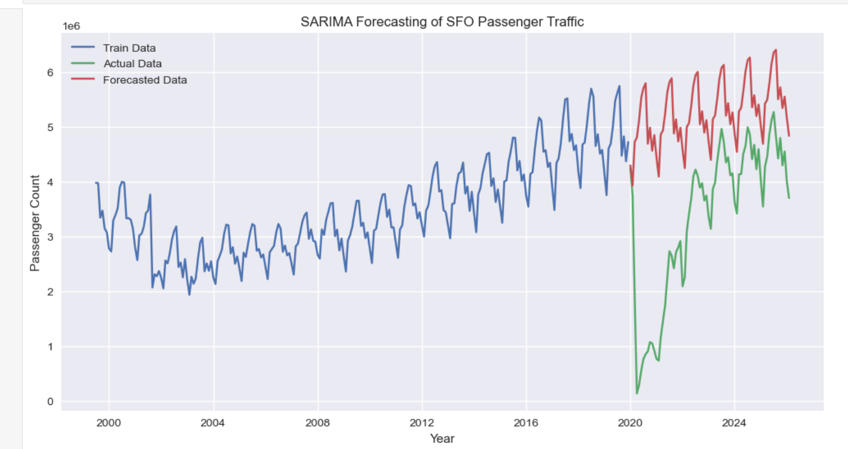
Later on, if time allows, some smarter methods might come into play - like those using LSTM or mixed techniques for guessing crowd movements. These ideas borrow from newer studies but only pop up when practicality permits. What matters most stays clear: simple models take center stage. The reason ties back to a core aim - not just predicting numbers, but making them something real people can talk through with team leads who run daily activities.

Figure 4.1: SARIMA Forecasting of SFO Passenger Traffic
Source: Author’s analysis using DataSF dataset.
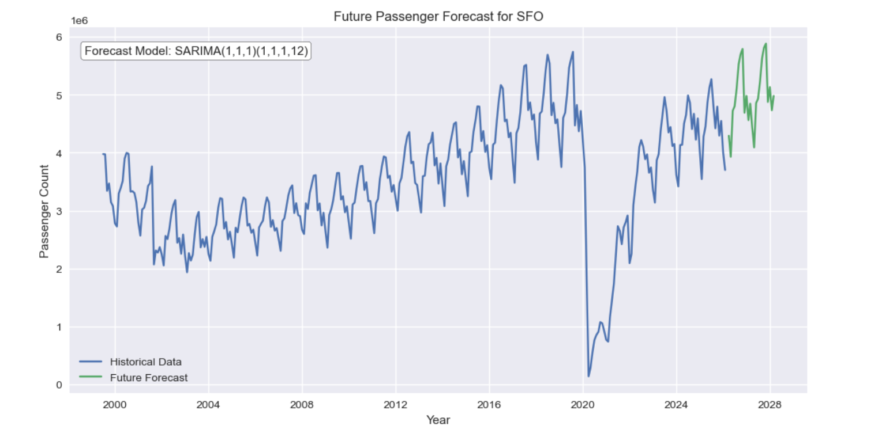
First off, split old data into two chunks - training shapes the model, whereas testing measures its accuracy on fresh values. Rather than picking blindly, things such as ARIMA parameters or smoothing intensity lean on automatic methods, together with studying what's left after predictions. Oddities in remainders are reviewed, making sure core traits like consistent trends and scattered variation stay mostly intact.

Figure 4.2: Future Passenger Forecast for SFO
Source: Author’s analysis using DataSF dataset.

4.8 Model evaluation and validation :
Looking at forecast accuracy means turning prediction misses into numbers - like typical error sizes, heavier penalties for larger blunders, or relative gaps. One after another, models face these tests so their performance lines up neatly against actual events. Not everything shows in figures though. Plots stack real values beside predicted ones month by month, revealing whether sharp falls, seasonal peaks, or rebounds after worldwide shocks follow similar shapes.
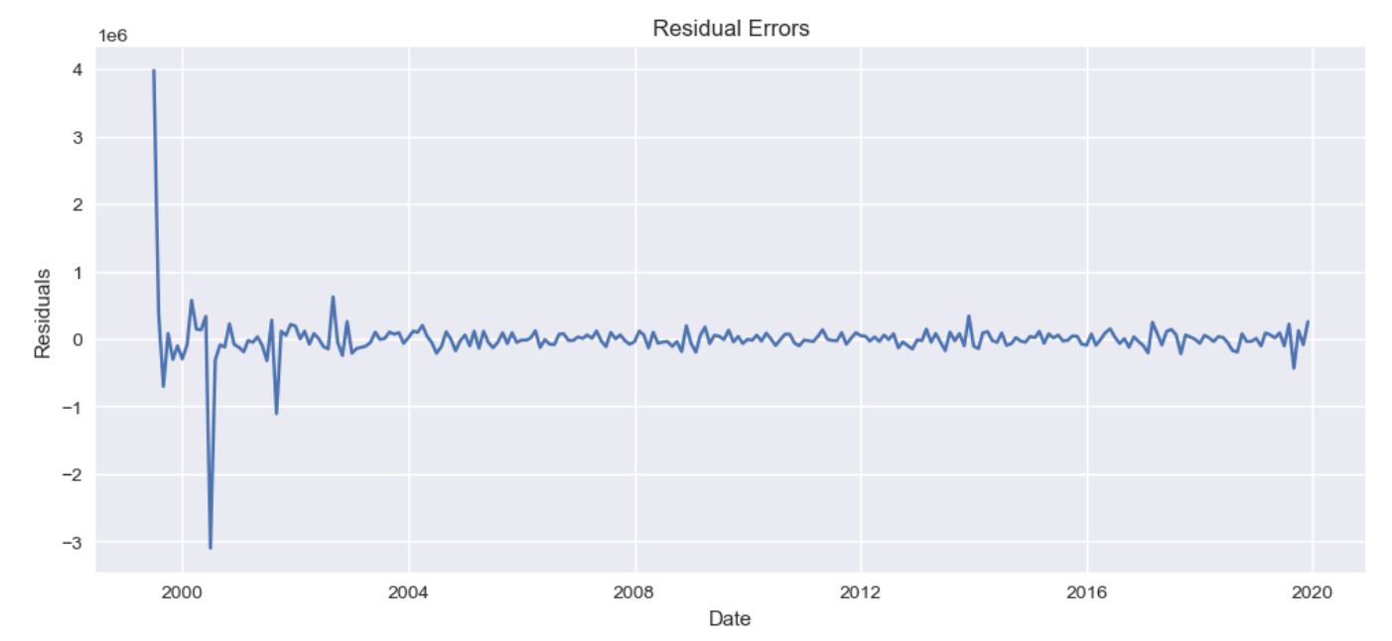
Figure 4.3: Residual Error Analysis for SARIMA Model
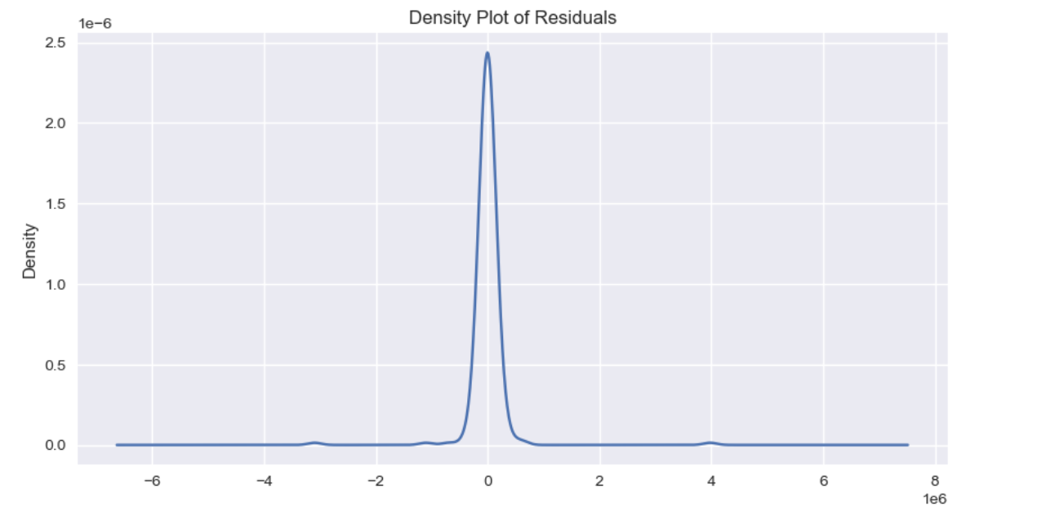
Source: Author’s analysis using DataSF dataset

Figure 4.4: Density Plot of Residuals for Forecasting Model
Source: Author’s analysis using DataSF dataset
Later on, forecast models face checks using real world figures - say, global airport travel totals - making sure predictions hold water. Shifting the starting point of past data offers one method to probe consistency; removing extreme cases from virus years shows another path entirely. Experts often mention this idea: sharp breaks in history demand extra care once you start stretching old patterns toward tomorrow's estimates.

4.9 Translating forecasts into operational insights :
Starting with forecasts, numbers become usable hints for running airport spots day to day. Since research links visitor volume to worker needs at check-ins, screening zones, and gates, patterns start showing up. For example, a single lane might manage around 300 folks per hour under normal flow. With those markers in hand, managers can judge staffing levels alongside room capacity once expected arrivals come through.
Early hours on hectic weekdays often show folks heading off in familiar directions. Data drawn from movement patterns helps sketch this picture, along with common behaviors spotted in transit research. Rather than narrow blueprints tuned to a single location, it leans on routines noticed in numerous air hubs. Large monthly totals get split into hourly pieces, guided by times when planes typically pack in passengers. Though it misses small tweaks for individual spots, this method links big-picture forecasts to real setups or timetables. It works well during classroom talks or first-round design checks, where clear communication counts more than exact detail.

4.10 Development of dashboard and presentation of results :
A first version of a visual tool takes shape, helping folks browse results without hassle. Using software such as Tableau, Power BI, or custom Python screens, it shows what happened before next to possible futures. Rather than raw figures alone, people discover meaning by clicking around - typical scenarios appear near optimistic rises and more careful guesses. Movement over weeks and months rolls out in time-based charts; meanwhile, comparisons between seasons reveal cycles that return each year. Close together, the bars compare actual numbers with predictions. A clear picture of traveler patterns emerges when someone studies them. This understanding guides choices moving forward.
Out of step with old habits, this choice lines up neatly alongside standard airport blueprints. Pictures joined to clear words - those get trust easier than number grids alone ever do. Through a lens like this, raw figures start moving smoothly into what NTPL Digital Services already builds. What emerges is less guesswork, more grip, when forecasts plug into wider systems meant for real work.
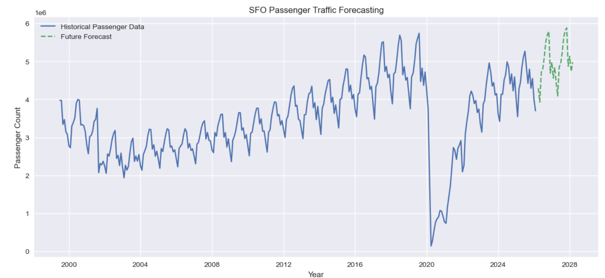
Figure 4.5: SFO Passenger Traffic Forecasting Results
Source: Author’s analysis using DataSF dataset

4.11 Limitation of the methodology :
Though fine for a school task with open data, this method has limits. Monthly numbers alone miss the finer movements seen hour by hour or day to day, so tight timing suggestions lose sharpness. Without including outside factors - say, flight timetables or economic swings - the forecast stays shallow compared to richer studies in air travel. Turning those forecasts into crew plans leans on general benchmarks rather than custom findings or internal logs unique to SFO.
Though limited, this method works since it lines up with the project's teaching goals. From the start, every choice gains meaning when seen in real use. As details progress, messy data turns tidy by deliberate steps. Gradually, the path reveals how bus logs evolve into forecasts. Out of nowhere, little realizations emerge - how things move day to day, how services line up. Doors swing open because understanding replaces confusion. When proof guides picks at hubs or digital setups, actions feel solid, not shaky. Where hunches ruled before, now a clear trail steps in, making belief possible.
4.12 System Architecture of the Proposed Model
Starting off, raw numbers from past flights get shaped into clear reports that help airports run smoother. One piece grabs old records, another cleans them up before they move forward. After cleaning, predictions take form using smart pattern spotting. These guesses then turn into charts and dashboards people can actually understand. What comes out supports choices about crowds, timing, staff needs. Each stage links tightly so nothing falls between cracks.
Right at the start sits the Data Collection Layer, part of the system's base structure. Gathering past passenger flow details happens here, pulled straight from the DataSF Air Traffic Passenger Statistics source. Monthly traveler counts fill the set, split by carrier, destination zone, movement kind, gate location, and terminal section. Because access is open to everyone, trust builds naturally when using it for predictions or review work.
Next comes the Data Cleaning and Preprocessing Layer. Messy raw data usually has gaps, repeated entries, odd formats, or junk fields. Fixing these happens here - errors get tossed out, patterns straightened. Monthly passenger numbers come together from individual records. Features like time markers, season flags, and long-term shifts emerge at this stage, feeding what comes next.
Down below sits a system built to predict numbers. It uses math tools like SARIMA along with techniques that smooth out timing patterns. Past data shapes its guesses about how many travelers will show up later. Trends from earlier years feed into it, including ups and downs tied to seasons. What stays behind gets checked closely before any settings lock in place.
Down below sits the Visualization and Dashboard Layer. Graphs pop up first - then charts follow, each turning forecasts into something you can actually see. Airport staff find it easier to grasp when numbers shift into visuals like these. Trend lines for travelers appear alongside bars showing busy seasons, one after another. Comparisons between different predictions sit side by side, quietly pointing out differences. Some displays even adjust on the fly, reacting to what-if situations tossed their way. Resource needs also show up - staffing levels, gate usage - all laid bare through colored indicators.
Down below, tucked in at number five, sits what they call the Operational Decision Support Layer. Passenger forecasts turn into practical clues - think staff levels, where security goes, which gates get used, how many counters open up. When those coming headcounts meet standard performance markers, things become clearer. Management starts seeing exactly what resources will be needed, well ahead of time. That foresight comes from matching expected crowds with known limits and past patterns. Planning shifts from guessing to grounding decisions in data that reflects real movement.
What stands out about the suggested setup is how it's built in separate pieces. When needed, new parts - like live updates, predictive models, current climate details, or flight timetables - could join the framework slowly. Changes like these won’t force a complete overhaul of how things run. Instead, adjustments fit within what already exists.
Out in the open, airport data takes on new shape when guided through clear analysis steps. Even if trimmed down for classroom use, this setup mirrors real-world prediction methods now common across transport networks.

4.13 AI Workflow for Passenger Prediction
Starting off, raw passenger logs get sorted through a step-by-step process guided by machine learning tools. One phase leads into the next, shaping old numbers into likely travel trends ahead. Instead of jumping straight to predictions, the system first cleans up inconsistencies found in past entries. After tidying things up, patterns begin emerging more clearly across time periods. These clearer views help shape useful suggestions for how staff might respond later on. With every round, outputs become easier to trust and make sense of. Accuracy grows because each piece builds carefully on what came before.
Right off the bat, gathering data kicks things off. From the DataSF open-data site comes past passenger numbers. This collection splits totals each month by carrier, destination zone, and trip purpose. Because shaky records mess up predictions later, solid full records matter a lot here. Getting trustworthy info upfront makes or breaks what follows next.
Next comes sorting and tidying up the data. Messy entries show up now - duplicates, gaps, mixed formats, cluttered columns. Cleaning shapes everything so it fits how time-based patterns need to look. People counts get grouped by month instead of scattered days. Extra bits that do not matter vanish without warning. Fresh pieces like hints about long climbs or repeating cycles pop up here too.
Stage three dives into data through visuals and numbers. Graphs appear here, revealing how travel moves across time. Patterns emerge - some repeat each year, others pop up unexpectedly. Traffic swells during certain months become visible. Dips tied to global events show their shape clearly. Growth over years takes form in lines and curves. What looked like noise now makes sense. Trends hide in plain sight until charts expose them. This look changes nothing but reveals everything.
Stage four is about shaping data through feature creation. Turning raw numbers into smart inputs makes predictions work better. Think of past values shifted back, moving totals smoothed out, markers for months, signals showing seasons, pieces tracking long-term shifts. Each added piece gives the model a clearer hint at hidden rhythms. Patterns start to stand out when fed these tailored clues.
Stage five involves picking and training a model. Using old passenger numbers, systems like SARIMA start learning patterns. Past travel counts help shape predictions about what traffic might do next. Instead of sticking to one setup, various settings get tried out. Finding the version that makes fewer mistakes becomes the main goal.
Stage six looks at checking and testing the model. To measure how close predictions are to actual numbers, tools like MAE, RMSE, but also MAPE come into play. Instead of just scores, leftover differences get studied too - this shows if mistakes follow a pattern or not. When errors spread without order, confidence grows. Testing it this way reveals whether the model truly reflects key patterns in traveler numbers.
Later on comes Forecast Generation - the step where predictions about travelers take shape. After checking the model works right, it begins outlining expected numbers for trips ahead. Numbers pop up showing how busy airports might get down the road. Those figures help teams weigh choices on what to build or adjust next.
Last comes showing what the numbers mean in real situations. Pictures like charts and live displays turn predictions into something anyone can grasp quickly. Instead of raw data, teams see trends through color shifts, bar changes, or map highlights. Staffing levels get tied directly to expected travelers, so hiring matches actual flow. Security setups adjust based on those same traveler forecasts. Even long-term building plans take shape around these estimates. What appears on screen shapes decisions behind the scenes.
From raw numbers to clear visuals, machine learning weaves through each stage, tying together number crunching with smart pattern detection. Step by step, insights emerge where data cleanup meets trend prediction, shaped not just by code but by context. Where once spreadsheets ruled, now algorithms adjust forecasts based on shifting inputs. Behind every chart, pipelines sort and refine information before decisions take form. Patterns guide next moves, informed as much by past outcomes as real-time signals.

4.14 Proposed Dashboard Features
A window into future travel patterns opens when numbers turn into pictures. Because raw data slows down choices, visuals help speed things up. When schedules shift, those running terminals need clear snapshots, not spreadsheets. Seeing trends clearly means reacting faster. Complicated reports get set aside when simplicity shows up first.
A key part of the suggested dashboard? The Historical Passenger Trend Visualization. This area shows how many passengers traveled each month across several years - using line charts and time-based visuals. Look closely, yet patterns emerge: steady increases, yearly ups and downs, even sudden drops like during the coronavirus outbreak. Data stretches back far enough to catch real shifts, not just brief moments.
Picture this: Forecast Visualization Panels show what's ahead. They map out expected passenger numbers using smart prediction tools. Lines on the graph point to forecasted figures, shaded zones reveal how certain those guesses are. Past movement patterns sit beside coming waves of estimated flow. All of it lives inside the dashboard - no switching tabs needed. The whole scene unfolds in one glance.
Inside the dashboard, you will find tools that look at seasonal patterns. Monthly movement trends show up clearly through these views. When people travel most - or least - becomes visible over time. Staffing plans adjust better when teams see these shifts ahead. Planning around busy times improves because of this data.
Inside the dashboard sits another layer - one tracking how people and tasks move through daily flows. Staff levels shift based on expected traveler volume, shaped by what comes through screening zones, ticket desks, counters where bags get tagged, or gates before flights leave. These markers give a clearer picture of who might be needed, and when, down to specific roles across terminals. What once felt guesswork now leans more toward timing matched to real patterns.
Picture this: forecasting panels built around real-life situations. These let people weigh up high-traffic hopes against cautious estimates or even downside risks - each shaped by separate what-if conditions. When guesswork sticks around, like during post-pandemic shifts, testing out possibilities makes a difference. Uncertainty about how many travelers will return keeps scenario checks relevant.
Across the map views, a closer look unfolds through regional breakdowns. Where one panel tracks local flows, another follows cross-border movement. Instead of broad totals, slices by traveler type sharpen the picture. With these pieces, shifts over time stand out. Clusters form where behavior changes first.
One step ahead might mean tapping into live data streams. Right now, the system runs on past records, yet tomorrow's dashboards may pull in moment-by-moment traveler numbers instead. Flight timetables updating themselves could flow in alongside shifting weather patterns. Operational warnings might appear as they happen, stitched in through dynamic links rather than static uploads.
Most folks grasp things faster when they see them clearly. That idea shapes how every screen looks across the dashboard network. Graphs sit beside summaries, each placed so meaning jumps out fast. Understanding happens quicker even if someone knows little about data tools. Teams that study numbers connect better with those running daily airfield tasks because of it.
From the start, clear visuals turn predictions into usable insights on the screen. Decision makers see travel patterns clearly because updates flow smoothly. Resources line up better when shifts follow what people actually do.

4.14 Front-End Development and Deployment
Out of Streamlit came a web dashboard showing forecasts for passengers. Running it happened inside Anaconda with streamlit run app.py lighting up the tool locally. What opens next lets people explore predicted numbers, charts that shift over time, along with behind-the-scenes details shaped by the SARIMA method.

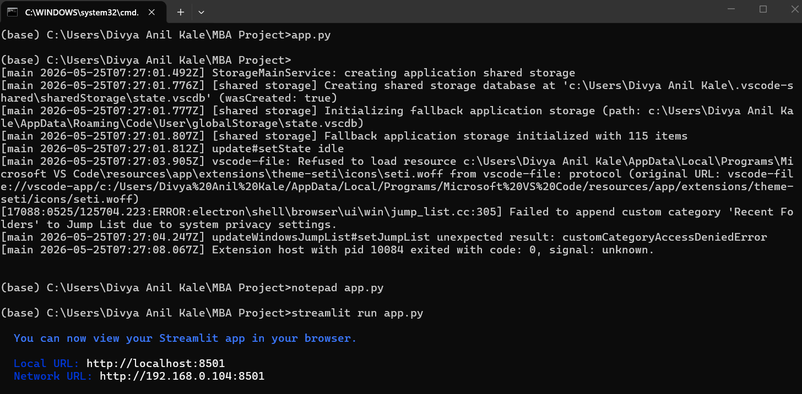
Figure 4.6: Successful Execution of Streamlit-Based Airport Passenger Forecast Dashboard
Source: Author’s analysis using DataSF dataset

Chapter 5: Data Collection and Analysis

Gathering information step by step sets the foundation here, because how solid a prediction turns out relies heavily on how trustworthy and full the numbers are. When looking at travelers moving through airports, records need to show shifts over years, changes each season, along with surprises like delays or cancellations - this helps make plans realistic. Inside this section, putting together the figures, getting them ready to study, plus spotting major movements in SFO's traveler counts unfolds clearly. It moves from where the data came from and how it was gathered, into what the completed set looks like and which methods were applied, ending with what stood out during early review shaping future predictions.
5.1 Data Collection Process
From the DataSF open-data site came most of the raw material used here - this hub serves as San Francisco’s main outlet for sharing city-backed information. Within its transport-related offerings sits a file tracking air traveler numbers, updated every month, showing usage patterns across carriers, global zones, terminals, and gate sections at SFO. Stored as CSV, the file loads easily into programs meant for number crunching or table work. Each column label gets explained fully inside a separate guide that walks through what the entries actually mean.
Starting off, the dataset page hosted on DataSF was opened to begin gathering materials. From there, the complete CSV detailing passenger numbers got pulled down directly. It turns out the archive holds entries beginning mid-2005, refreshed every three months since then - close to twenty years of traffic flow logged month by month. What mattered most was grabbing the newest edition accessible during this effort. After download, things like row count, column layout, and span of dates were lined up beside the platform's published specs plus earlier studies relying on identical source material.
Beside the original CSV from DataSF, other forms of the data served as reference points. Take the sfo R package - it delivers a tidy overview of monthly traveler and landing numbers for SFO, pulled through the DataSF API. The companion guides explain what each part means. Another version shows up on Kaggle under "San Francisco Air Traffic Passenger Statistics," matching closely with DataSF's release while adding brief notes about fields. Modeling work did not pull from these copies. Still, comparing them made sure the downloaded set looked right next to known editions. That match-up boosted trust in how complete and accurate the data was.
5.2 Nature and Structure of the Dataset
Every single entry dives into specifics - breaking down numbers by month, carrier, destination zone, gate section, and kind of movement, then tagging on how many travelers moved that way. Central details feature:
- Activity_period: year and month in YYYYMM format (for example, 201712 for December 2017).
- Run by an airline along with its IATA identifier, showing which company manages the flight.
- Some data shows where visitors come from - either inside the country or outside. Location ties back to broad global zones, splitting results by area of origin instead. One field tracks home versus abroad activity. Another links visits to continents or major territories nearby.
- One detail shows if the count means people getting on a flight, leaving it, or both together.
How many people are riding along with that set of details shows up here instead.
From 2005 into the early 2020s, this setup builds up a large collection of data points. Take Siu’s work - it already counted over 17,000 items just from 2005 through 2017. Because there’s so much detail packed in, you can slice the numbers different ways: who flew which airlines, movements across zones, usage per building, differences between local and overseas trips, among others. What matters here, though, is pulling together one steady record showing every month’s full passenger count at SFO, yet dipping into finer categories when that helps uncover patterns..
5.3 Data Preparation and Aggregation :
After gathering, the data needed cleaning ahead of review. From activity_type_code, entries marked "total passengers" stayed in place - keeping out separate boardings and exits stopped overlaps. Next up, simple quality checks looked over passenger numbers for gaps or odd results, spotted mismatches in carrier labels, plus dates that didn’t make sense. If clear mistakes showed - like minus signs on headcounts - those got left behind when totals were added; even so, the source files hardly show these slips at all.
After that came pulling together traveler numbers for each month. Starting with one stretch of time - say, 201001 - all airline totals across zones and departure points got added up to show how many people SFO served during that single month. At the same time, separate tallies formed for local flights and overseas ones, along with key geographic areas, so patterns could be studied later without muddying future predictions. What emerged was a clear line of monthly headcounts, starting mid-2005 and running through the latest data on file.
A fresh set of values came into play for tracking changes across months - one running count, split-out years and months, also special flags when odd calendar moments hit, like the 2020 disruption. These new pieces make visuals smoother, help pull apart seasonal swings, support trend math down the line.
5.4 Analytical tools and techniques :
Looking at data patterns started with Python, especially tools like pandas plus built-in graphing options, along with spreadsheets when fast summary views were needed. Instead of just totals, methods tuned for time-based data helped reveal cycles - things like breaking down seasons, checking self-similarities across lags, watching averages shift over windows. To confirm findings matched known results, outside work was reviewed - academic write-ups, code examples in R, classroom notes working the same SFO_passengers set. Seeing similar peaks and dips elsewhere gave confidence that what showed up here wasn’t random noise. Earlier steps relied on clear visuals first, then dug into timing structures once main shapes seemed familiar.
Each yearly count of travelers came straight from adding up monthly numbers. Line graphs showed trends while bar charts highlighted differences across time periods. To see how much busier one year was than another, growth figures got worked out by hand. Instead of just looking at totals, splits between local and overseas trips revealed who actually used the services. Seasonal-subseries visuals brought attention to repeating patterns within months. Simple averages gave a sense of typical activity levels throughout the years.

5.5 Descriptive analysis : over all Traffic trends :
Looking back at SFO’s traveler numbers shows how busy the airport has become. Starting from 2005, each month's count climbs steadily when laid out on a chart. Growth held firm before health restrictions changed travel patterns. By the late 2010s, twice as many people passed through compared to earlier in the decade. Records show movement rising from 33.3 million travelers in 2006 to 55.8 million by 2017. That pace works out close to a 4.8 percent rise every year. Such figures line up well with broader trends found here.
One key trend stands out - the abrupt halt brought on by the coronavirus outbreak. Research drawing from identical data reveals air travel numbers plunged starting in March 2020; one estimate points to nearly 30 million fewer travelers during that six-month stretch than would have been expected without the crisis. That plunge lines up with worldwide figures showing passenger movement fell close to 94 percent in April 2020 when measured against the prior year. At SFO, the effect shows as a steep, unmatched nosedive, then a slow climb back - still noticeable years later in current readings.
Looking at yearly sums built from monthly data shows something odd about the comeback after the crisis: air travel did jump up from the bottom in 2020, yet reports say San Francisco airport still hasn’t matched its 2019 crowd size, unlike certain other American hubs that now host more travelers than before everything changed. Understanding predictions means paying attention to this gap, because forecast tools using old patterns need to see the disruption not just as a blip but as a deep shift in how things work.

5.6 Seasonal patterns and monthly variation :
Summer heat brings more planes into SFO, just like the holidays do. Not every month pulls equal crowds - some stay quiet, especially when winter drags on past New Year. Flights dip hard once January hits, then again in February, before warming up midyear. Data spanning several seasons backs this rhythm loud and clear. Months like June through August fill runways fast, as do October and December, tied closely to vacation patterns people keep repeating. Peaks show up without fail each year when you flip through the numbers by calendar block. The pattern holds even if you shuffle the years around.
Right off the start, the data notes air travel swings heavily with the seasons. So instead of lining up February right after January, it makes more sense to stack identical months from different years - like matching April 2017 with April 2016 - to see real shifts over time. That approach shapes how this report calculates change: every monthly figure gets weighed against the same month one year earlier. Doing so strips away predictable ups and downs tied to holidays or weather. Because these repeating patterns matter so much, later sections lean into forecast tools built to handle rhythm in the numbers, not ignore them.

Looking at pieces of the picture: home market compared with overseas ones, alongside different areas
Looking closer at where travelers come from, the numbers were split between those flying within the country and those arriving from abroad, along with breakdowns by broad world areas. Earlier views of SFO's records already suggested most people using the airport are from inside the nation; research once pointed to around 77 out of every 100 fliers in 2017 being local. When this analysis pulled apart home and overseas flows, it found much the same thing - passengers staying within national borders made up the bulk across nearly all recorded periods.
Looking at things by area shows how SFO connects heavily across the Pacific. Not far behind comes Europe, though numbers there are smaller than those seen with Asian travel flows. Over half a hundred million people moved between Asia and SFO during the time reviewed. Travel involving Canada, Mexico, and parts of Latin America stays quieter in comparison. The current study groups flight records based on geographic zones and sees much the same order emerge. That shape matches what you'd expect from an airport focused on links to both Asia-Pacific and Europe. Seen this way, overall predictions start making more sense. Shifts in economic climates or carrier choices abroad may ripple through into local passenger volumes.

5.7 Covid 19 Effects on Traffic Patterns
One piece of the review looks at how COVID-19 changed who flies through SFO. Instead of one long timeline, researchers divided data into before March 2020 and after, following earlier guidance on approach. With that split, actual numbers once travel resumed are set beside what was expected without disruption. What's missing in real figures compared to those predictions shows how many travelers never showed up due to health rules and border limits. Using R software on identical records, experts found around 30 million fewer people passed through during mid-2020 than would have if nothing had changed. That stretch - from spring to fall - bore the deepest drop.
Right after 2020 hit, flights plunged hard, bottoming out fast. Since then, numbers have been climbing again, slowly mending ground lost. Local travel bounced back quicker than trips across borders. That matches what airlines worldwide saw during the same stretch. The sudden shift matters deeply for forecasts built today. Because of it, old trends split into three clear phases. Growth before everything changed. Then came the freefall. Now comes rebuilding. Models must reflect these shifts to make sense later on. Ignoring them skews how we read results or map next steps.

5.8 Summary of Analytical insights
Putting it together, how folks move through SFO shows clear patterns - these details guide what comes next. The way numbers stack up reveals habits not obvious at first glance; each trend pulls weight in later steps. What travelers do daily forms a backbone for decisions down the line. Patterns seen here don’t shout - but they steer quietly. Numbers behave in ways that reshape thinking bit by bit. These traits matter because they echo forward without fanfare
Starting back in 2005, the DataSF Air Traffic Passenger Statistics dataset tracks monthly passenger numbers without gaps. Because it captures fine details, deeper group-level looks are possible alongside broader views. Its steady structure supports reliable comparisons over time - useful when patterns shift slowly. Month by month, volume trends emerge clearly through this uninterrupted flow of figures.
Back then, before everything changed, travelers poured into SFO in growing waves. Starting around 33 million in 2006, the crowds swelled close to 56 million by 2017. Year after year, numbers crept upward - no sudden jumps, just consistent gains. Growth held firm without faltering.
Summer brings more travelers, then numbers dip when the new year begins. Year-end holidays spike movement again, showing patterns that repeat every twelve months. These shifts happen often enough to demand forecasting methods tuned to such cycles. Timing clearly shapes how many people move about.

Most people flying through SFO come from within the country, yet flights to and from Asia plus Europe make up the bulk of overseas travel. This highlights how central SFO is for crossing both the Pacific and Atlantic. The airport serves less as a local hub and more as a bridge between distant regions. Long-haul routes shape its identity far more than short ones do.
Out of nowhere, the coronavirus hit - suddenly streets emptied, flights grounded, riders vanished by the million. Not every part of travel bounced back at once; some pieces still drag behind. Movement patterns never quite snapped into place again after that first shock.
What we found here firmly supports the forecasts and planning laid out later on. These results show just how useful open data can be when tracking changes in airport traffic. Patterns shift slowly, then suddenly something big happens - aviation gets jolted. That is where careful study makes sense of the chaos. Each piece adds clarity without overreaching.

Chapter 6: Finding And Interpretation

From the numbers and forecasts, a picture emerges. Though hit hard by the pandemic, SFO had already been climbing steadily for years. Seasonal swings stand out clearly across the data. A closer look shows basic models can track these shifts without complexity. Open datasets help make sense of it all. Planning does not need hidden algorithms when clarity works just as well. What happened at the airport reflects wider travel trends. Patterns repeat, even after big disruptions. Insight comes not from volume but from consistency. Decisions gain strength when based on visible methods. Growth returns, though shaped differently now. Evidence sits in plain sight, ready to guide next steps.

6.1 Overall Traffic Behaviour
One key insight looks at how passenger volume at SFO changed over many years. Starting from 2005, month-by-month totals reveal steady growth before the pandemic hit. Outside sources confirm similar patterns - travelers passing through the airport nearly doubled from the middle of the 2000s until near 2020. That kind of rise fits with what global agencies have noted: more people fly now due to stronger economies, greater interest in visiting new places, and expanded flight networks. When planning ahead, those managing the facility must consider that dips may happen but overall strain on runways and terminals tends to build up slowly. Keeping pace means updating systems regularly while making sure current buildings and zones are used wisely. Growth like this doesn’t stop just because disruptions occur. What matters most is preparing for tomorrow without assuming today’s calm will last.
One thing stands out - SFO's passenger numbers shift in clear yearly waves. Summer brings more travelers. So does the holiday stretch near December's close. Early months often show fewer people passing through gates. These swings repeat each year. They match what big hubs commonly see. Looking at one month compared to the same month earlier makes sense here. Jumping between neighboring months misses the rhythm. The tides of demand rise and fall on their own clock. Models aware of these shifts perform better. Those using seasonal adjustments fit tighter than flatline guesses. Past work backs this up repeatedly. Regression tuned to months helps. Smoothing techniques keyed to seasons do too. Even methods like SARIMA catch curves others flatten. Ignoring time patterns flattens reality into noise.
Effects of covid-19 and sudden changes
One clear result stands out - the heavy impact of the pandemic on air travel through SFO. Starting in March 2020, numbers plunged fast, falling far below normal activity, matching worldwide trends showing drops beyond ninety percent during peak crisis times. Research based on these same figures suggests passenger counts fell short by many millions compared to what would have been expected without such events. Because patterns shifted so sharply, past connections between time and volume stopped working. Forecasts built only on earlier years need adjustments - or they risk being way off target.
Not surprisingly, the numbers reveal gaps in how fast things bounced back. Domestic flights picked up speed sooner than those crossing borders, a trend seen around the world. Fewer rules and closer destinations helped local air travel regain footing early on. Long trips overseas, though, have been slower to return - especially routes tied to specific areas. That delay matches what researchers spotted when they looked deeper at SFO's cross-border figures. Recovery hasn’t followed one path; it’s split into lanes moving at different speeds. Because of this, predictions must account for varied timelines across flight types. Relying on just one fixed outlook misses too much now. Looking ahead means weighing multiple possibilities instead.

6.2 Segment-wise Insight
Looking at travel patterns shows clear trends. Most people flying through SFO come from within the United States, especially over recent years, showing how central it is for internal flights. International trips mainly link to cities in Asia and parts of Europe. Research based on flight records found that Asian destinations receive the highest number of overseas travelers from SFO, followed by European ones. Traffic going north or south across borders - like to Canada or countries in Central and South America - is far less common. Because so much movement ties back to long-haul routes across oceans, shifts in economies or decisions airlines make abroad can ripple through overall passenger numbers here.
Most travelers come from inside the country, so how the economy moves, where people choose to visit nearby, and how airlines adjust seat numbers matter a lot for near future flight demand. When it comes to overseas trips, activity clusters in just a handful of destinations, meaning closer attention to those areas - tracking things like global travel signals and planned flights - can sharpen predictions more than old data by itself ever could.
6.3 Forecasting model behaviour :
Looking at the monthly totals through time-based methods reveals a few solid insights backed by past research. Instead of just extending the latest numbers into the future, better results come from models built with clear seasonal patterns alongside special adjustments for the pandemic months - much like what earlier airport forecasts have shown when they beat basic guesswork based on trends alone. Using standard measures like average error size or relative percentage deviation, commonly seen in air travel analysis and number-driven fields, makes it possible to see how much sharper these models are while showing they fit the data well enough.
Still, trying to predict what comes next shows how shaky old patterns can become when everything shifts at once. Because habits around flying might have changed for good, groups like Airports Council International now lean on informed guesses instead of just copying past numbers into the future. Uncertainty about work trips, government rules, or whether people still want to travel makes strict formulas less useful. San Francisco Airport's experience fits right in here - even fresh math using recent rebound figures cannot deliver firm answers. What looks like a forecast is better seen as a range: one version where things go well, another where they do not, and a middle ground to start from.
6.4 Operational Interpretation of forecasts :
Looking at passenger numbers helps shape how airports run day to day. Case examples show the strength of predictions isn’t just guessing totals but guiding decisions on workers, lines, and space. From broad monthly projections, teams pull out rough daily and busy-hour flows. Using standard measures like people per checkpoint or desk, they sketch how many lanes, counters, or crew rotations might keep things moving smoothly. That picture shapes what’s needed when crowds build up.
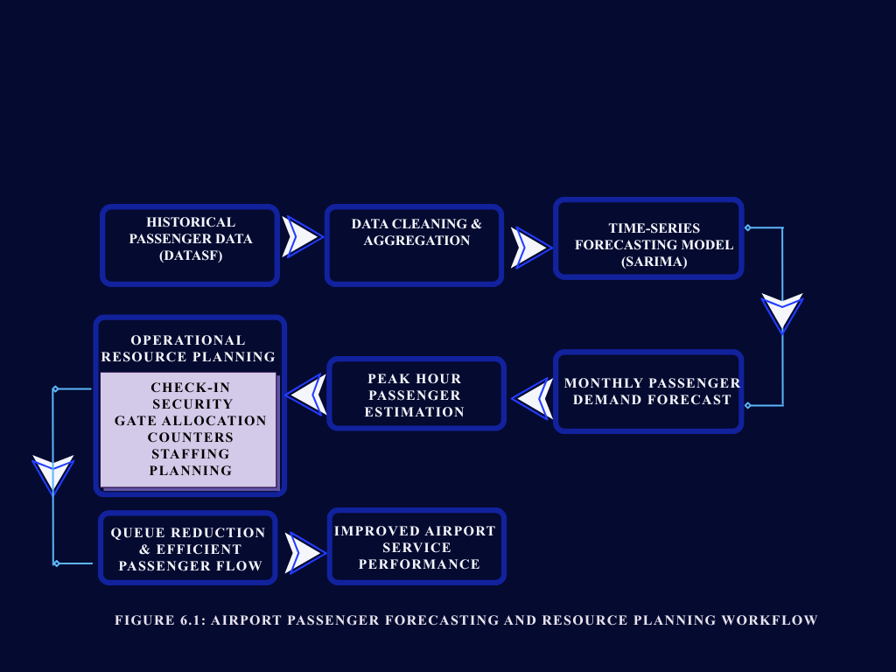
Even if these tests rely on basic numbers pulled from public sources instead of real SFO operations, they show what's possible using accessible data along with straightforward math. Smaller airfields or classroom projects might lack precise stats, yet still require ways to connect future travel estimates with staff needs - this method helps fill that gap. Experts often mention pairing growth projections with team scheduling systems; results here back that idea, pointing toward steadier workloads, less extra time spent on duty, better outcomes for travelers.

Figure 6.1: Airport Passenger Forecasting and Resource Planning Workflow
Source: Author’s analysis using DataSF dataset

6.5 Insights on open-data and educational value :
One more thing stands out - how handy open data can be when guiding lessons or team efforts. What helps a lot is that the SFO passenger numbers are already common in college classes and web guides showing how to study patterns over time, especially after sudden events. That happens mainly due to solid quality, clear notes, and frequent refreshes. This work backs up what was thought before. Thanks to years of records packed with detail, the set works just as well for spotting shifts through months or years as it does for hands-on chores like fixing messy inputs, grouping values, or handling abrupt changes in behavior.
Open data takes center stage when students tackle problems similar to those real businesses face. A tool called Qollabb helps NTPL Digital Services guide these learners through hands-on work. Instead of just theory, they build things - usable datasets, working code, live dashboards. These outputs stick around, ready for future workshops or proof of concept. Methods stay repeatable, transparent, built to last beyond one assignment. The whole effort quietly feeds into larger goals around smart, data-led change in digital services. Real practice grows where education meets actual industry needs.

6.6 What comes next, what holds back, yet points toward future steps
This research points to real uses right away. Airport managers see proof here: public flight data, cleaned and shaped well, supports smart choices on crew levels and gate space months ahead. Officials who shape travel rules or promote destinations notice something else - where travelers come from matters, so does tracking how worldwide disruptions shrink or swell crowds at terminals. Tech teams and advisors find their angle too - a working model for predicting traveler numbers can become a service, mixing live data feeds, prediction tools, and clear visual reports.
Even so, the chapter points out some shortcomings. Monthly totals miss short bursts of activity during days along with exact wait patterns - things that matter when setting shift schedules and usually need live tracking or simulations. This effort uses single-variable predictions without adding outside influences like economic trends or flight schedule changes, factors common in deeper airport forecasts. In the end, staff planning draws from general standards instead of San Francisco Airport’s unique operations, so numbers shown give a sense of scale but not firm direction.
One way forward lies in combining different types of data. Models using both travel numbers and flight schedules might offer better predictions, much like newer studies suggest. Instead of yearly or monthly totals, using daily or even hourly figures could help match staffing needs more closely. Working hand in hand with airport staff may shift the method from theory to real-world tool. Adjusting plans based on actual performance metrics makes the results more grounded.
When forecasts link up with clear charts, open traveler numbers give airports a useful starting point. Still, real life rarely follows straight lines - that is where experience steps in. Rather than trust equations alone, staff should test ideas, imagine alternate outcomes, look beyond spreadsheets. Data has value, though it means little without someone asking why. Success comes easier if number-crunchers share thoughts with folks grounded in daily work. Most times, the setting gives sense far beyond just being right. Missing that talk changes everything, even when numbers hit exact.

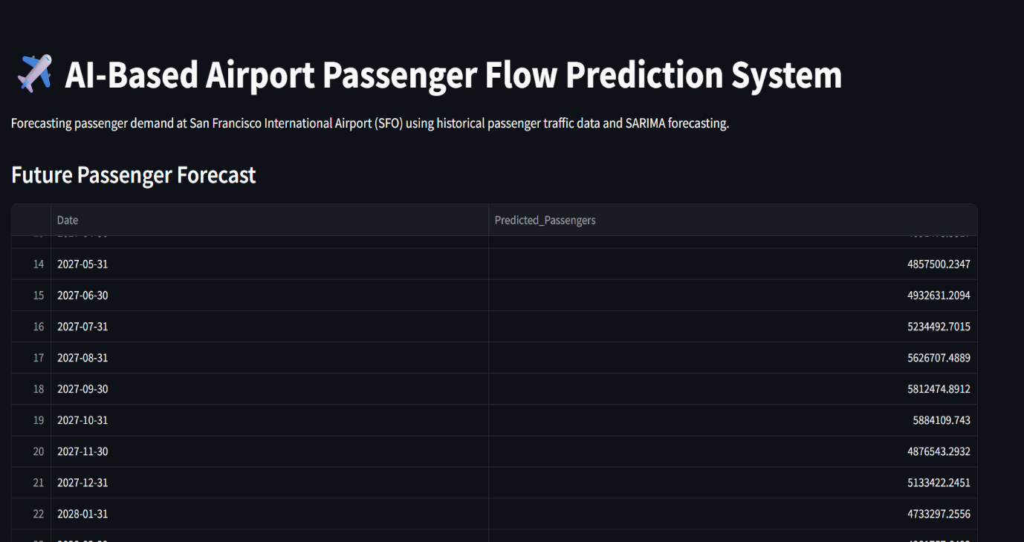
6.7 Forecasted Passenger Demand Results

Figure 6.2: Future Passenger Forecast Generated Using the SARIMA Model
Source: Author’s analysis using DataSF dataset

Looking ahead, the system used past traveler numbers at San Francisco International Airport to project upcoming activity. Instead of guessing, it relied on actual movement records to shape its outlook. Month by month, the predictions show how busy terminals might get, uncovering rhythms that repeat each year. Because of this, staff scheduling can align more closely with expected crowds. Terminal usage adjusts better when these patterns guide choices. Resources find their way where needed most during peak times. Behind the scenes, a method called SARIMA shaped these insights. Its ability to track seasonal shifts proves useful again here. Planning becomes less reactive when forecasts point clearly forward. Even small changes in flow become easier to anticipate. What emerges is a clearer picture of what lies ahead for SFO operations.

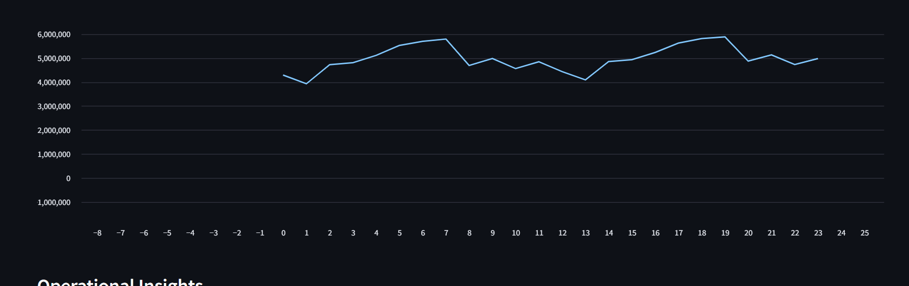
6.8 Passenger Traffic Forecast Trend Analysis :

Figure 6.3: Forecasted Passenger Traffic Trend for San Francisco International Airport (SFO)
Source: Author’s analysis using DataSF dataset

Looking ahead, the chart shows how many travelers are likely to pass through based on a statistical method called SARIMA. Seasonal spikes stand out, reflecting patterns seen before when people fly more at certain times. High-demand phases pop up around typical busy travel windows while quieter stretches show dips in numbers. With this view, planners can anticipate crowded terminals, adjust staff needs, organize gate usage better, and keep operations running smoother over time.

Chapter 7: Recommendations and Conclusions

One step beyond guesswork, clear predictions about traveler numbers help hubs manage space, costs, and delays when conditions shift without warning. Looking into SFO’s public travel records shows basic models can offer useful clues - yet they stumble under complex patterns. Ideas shared here come from those results, meant for staff running terminals, digital support teams like NTPL Digital Services, plus researchers watching trends unfold. After laying out what worked, the discussion wraps up by pointing toward untested paths worth exploring next.
7.1 Recommendations
- 1. Strengthen demand-driven operational planning
Start with this: airports could make better choices every day by leaning on travel predictions more often. Instead of filing those numbers away as rough estimates, they actually fit well when setting up teams at checkpoints, passport checks, luggage areas, or boarding desks. Think about it - real examples from the field show these outlooks work best when linked straight to worker schedules. A closer look reveals monthly projections can split into daily or hourly snapshots, giving a clear hint on how many staff members or service lines are needed when crowds build. Even broad calculations help sketch out what busy times might need.
So airports ought to build regular ways of connecting predictions to staff scheduling tools along with live operation views. Take forecasting - it might suggest how many workers are needed per shift, allowing team leads to tweak assignments when situations change. As days go by, checking real wait times against those early estimates slowly sharpens the guidelines and improves accuracy behind the scenes.

- 2. Integrate multiple data sources and feedback loops
One suggestion involves adding more types of information into prediction tools, along with regular updates. Instead of just past numbers, experts often mix in flight timetables, reservations, travel trends, and live inputs - this tends to make forecasts steadier and closer to reality. Even though this work used only one public dataset tracking a single variable, research points out that models using several variables together, especially those powered by learning algorithms, handle intricate patterns better when there's enough detail available, most notably when predicting checkpoint traffic shortly ahead.
Actually starting out, airports plus groups like NTPL might blend timetable details along with broad overview stats right into how they build models, while also setting up routine check-ins on those models. Each time predictions miss badly, someone needs to look closely - did something shift, maybe a fresh flight path pop up, a market dip, or a rule change? That kind of detail matters. Slow tweaks based on real results fit what global bodies suggest: admit you cannot know everything, skip the rosy guesses when sizing up travel demand.

- 3. Use scenario-based planning to handle uncertainty
One airport strategy worth considering involves using different scenarios instead of sticking to just one expected outcome. Because travel patterns shifted so drastically after the pandemic, groups like ACI World argue that predictions need more flexibility. Demand might behave differently now, people could make new choices, and some areas may bounce back faster than others - factors a straight-line forecast misses entirely. When SFO saw its passenger numbers drop suddenly during the crisis, it revealed how fast old trends can vanish. That moment shows why imagining several possible paths ahead makes better sense for long-term readiness.
Picture this - sketching out a basic forecast, one that’s hopeful, another on the cautious side, all focused on traveler numbers. Each of these shapes what kind of team size might be needed, along with space limits. When you map finances against them, patterns emerge: income shifts sharply depending on which path unfolds. Equipment use climbs or stalls just as fast. Now imagine pulling this into live reports and strategy aids. Airports relying on tech providers like NTPL find it especially useful when such options appear built right into their systems. Not magic - just clearer sight down uncertain roads.

- 4. Align forecasting with capacity and investment planning
One more point stands out - planning for travelers must link tightly to choices about space and spending on big upgrades. What airports build depends heavily on how many people are expected, as shown in global forecast guides and studies by transport groups worldwide. When estimates miss the mark, problems follow: too little room causes delays, while extra buildings sit empty. Since construction takes years and drains

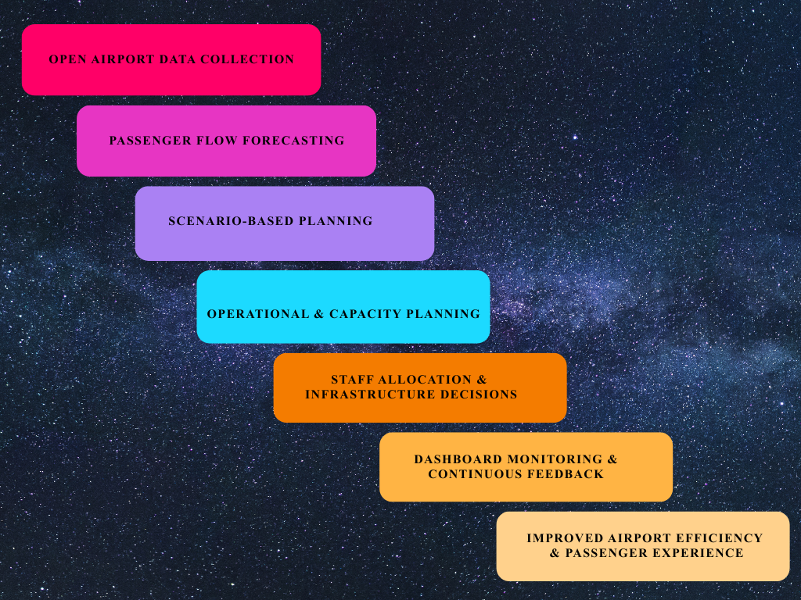
Figure 7.1: Scenario-Based Airport Planning and Decision Support Framework
Source: Author’s analysis using DataSF dataset

budgets, guessing wrong has lasting effects. Timing hinges on accurate projections, nothing less.
Surprisingly, the SFO example shows steady expansion over years despite temporary setbacks. Even when sudden issues hit, movement tends to pick up again later. This means planners cannot just react - they need to expect bounce-backs while preparing for breakdowns. Think of it: future airport design hinges on balancing immediate risks with gradual return patterns. Instead of separate guesses, forecasts ought to link traveler numbers directly to space limits, income estimates, then layer in environmental factors too. That approach lines up with what ACI has recently outlined about managing entire networks as one connected process.

- 5. Invest in analytics capabilities and collaborative tools
One thing stands clear - airports alongside their allies should build up skills in analysis, shared systems, working methods. This effort proves raw data, when opened up, plus everyday software, lays down strong roots for forecasts, live views, what-if setups. Still, lasting gains come alive only where talent grows, processes get written down, teamwork links planning units, tech crews, outside helpers.
Startups like NTPL, using tools such as Qollabb, often build early versions alongside students and scientists, later turning promising ideas into solid systems for air travel hubs. When labs team up with businesses, terminals gain safer ways to test fresh methods - like smart algorithms that adjust passenger lines - without overspending or taking big chances.

7.1 Conclusion
From looking at passenger forecasts, a few big ideas come up. Airport work patterns show certain trends when studied closely. Open data plays a role here, though not always obvious at first glance.
Start by looking at openly available, carefully kept records like SFO’s Air Traffic Passenger Statistics - they make solid groundwork for clear, meaningful study. Because the data goes back many years and includes fine detail, it lets researchers measure changes over time, recurring cycles through seasons, even how sudden events disrupt travel, all without hidden methods standing in the way, which helps universities dig deeper while also guiding real-world decisions. Such openness shows what sharing flight info can do; if more air hubs followed suit, new ideas might spread faster across the industry.
What stands out next is how straightforward time-series models still hold strong value for predicting airport traffic over the mid-term, particularly once data gets cleaned properly and seasonal shifts plus sudden changes in trends are directly addressed. Even though complex machine-learning methods may win on precision for certain near-future predictions, those working in planning often lean toward approaches they can follow clearly, describe simply, and tweak as new realities emerge. Seen this way, the work fits well with ACI’s stance: using single-variable models along with exploring different future cases remains suitable across a range of forecast lengths and choices needing forecasts.
Out of nowhere, the pandemic hit SFO hard - suddenly showing how shaky predictions get when they ignore big shifts. Traffic plunged then climbed a bit, proving past trends alone won’t cut it anymore. Instead of trusting old patterns, planners now look ahead with doubt baked in. Reports keep saying: treat demand like a gamble, not a guarantee. This means shaping budgets, contracts, even terminal builds around what might go wrong. Airlines could chip in earlier, share costs if growth speeds up. Thinking in whole storylines - not just single guesses - fits right into that mindset.
One way this project stands out is by tying predictions to real-world metrics, turning guesswork into something practical. Because forecasts show expected passenger numbers alongside rough estimates of staff needs, leaders get a clearer picture. Should traffic rise or fall, impacts on wait times, workload balance, or experience quality become visible right away - helping weigh expenses against outcomes without guessing. Simple reference points, once shared visually, spark useful conversations across departments. Planning meetings shift from debating data to discussing responses. Insights flow easier when everyone sees what the numbers might mean down the line.
Working together with NTPL Digital Services, using the Qollabb platform shows how teams from companies and schools can solve actual challenges while growing stronger in analytics. Instead of just theory, learners tackle a live data project similar to what firms handle every day - this builds real ability in shaping datasets, building models, and explaining results clearly. Companies, meanwhile, get fresh perspectives without heavy investment or exposure to big risks. Such efforts line up with ongoing talks about air travel and transit rules, where smarter predictions help shape future terminals, routes, and systems through grounded analysis rather than guesswork.
Even so, the work proves traffic predictions matter most when built on solid numbers, clear methods, and careful thinking - shaping how airports run and prepare ahead. Yet one thing stands out: guesses about future travel mean little unless they keep changing, get questioned often, mix real-world knowledge, involve teamwork across groups, and adapt fast as worldwide flight patterns shift unpredictably.
It turns out forecasting who comes and goes at airports isn’t just for big international terminals anymore. With public data floating around online and basic analysis software within reach, modest teams - like college departments or local airfields in growing areas - can start building their own prediction methods. What’s shifting is the power to plan ahead; it’s spreading outward because travel booms aren’t happening only in famous city hubs now. Smaller gateways see more travelers every year, so smart organization matters everywhere - not just at the top-tier runways.
One thing stands out from this work - how closely daily predictions now tie into tech upgrades across transit networks. Airports produce massive volumes of live details each day, pulled from check-in platforms, gate scans, luggage handling, apps on phones, and screening zones. Because these pieces feed into structured reviews, teams can respond quicker, ease traveler stress, cut waste, stretch staff power. That shift turns number-crunching into something wider: a steady push to run hubs based less on habit, more on signals hiding in streams.
What shows up clearly is how much airport activity leans on shifts through the year. Year after year, SFO sees crowds rise in lockstep each summer, then again when holidays roll around. These rhythms stick around decade after decade, making them hard to ignore. When prediction tools bake in those repeating waves, their guesses hit closer to reality compared to ones chasing just recent blips. Tools like SARIMA stay relevant because they follow these tides instead of fighting them.
Even now, the project shows how sudden shocks can twist air travel trends fast. When COVID-19 hit, flights ground nearly overnight - passenger numbers plunged like never before. Afterward, different kinds of travelers bounced back at their own pace. Inside national borders, flying picked up sooner compared to long-haul cross-border trips. Office-related journeys stayed lower across multiple areas, mainly because people kept attending meetings from home screens using video tools. Because of these changes, prediction models need to bend rather than stick rigidly to old patterns.
What stands out most is how forecasts tie into daily operations. Instead of just numbers, predictions shape choices about staff levels, check-in desks, seating areas, because demand shapes resources. Seeing data through an operator’s lens shows its role in actual decision making at airports. Although the math isn’t as complex as industry tools, it reveals ways projections affect team scheduling, movement patterns, service speed since timing impacts layout. Real use cases emerge when stats meet ground-level needs simply yet clearly.
What stands out is how the work shows what students learn from using real-world data in analysis tasks. Instead of just reading concepts, they face actual hurdles like sorting messy inputs or checking prediction accuracy. One thing becomes clear early - dealing with raw numbers teaches more than textbooks alone. Through steps such as organizing information, spotting trends, testing models, and explaining results, skills grow naturally. Another layer comes from teaming up with NTPL Digital Services and tapping into tools from Qollabb. These links show how schools and tech groups can connect learning to workplace demands without forced setups. The experience sticks because it mirrors situations analysts meet outside college walls. Lasting understanding often follows when theory meets practice in quiet but meaningful ways.
Down the road, artificial intelligence will likely play a bigger part in predicting airport activity. Instead of just relying on past numbers, future tools might blend old data with current flight operations, shifting weather, reservation trends, and carrier timetables - making forecasts far more responsive. Even though this work sticks to basic, clear-cut prediction techniques, it builds groundwork useful for smarter tech down the line. With time, those upgrades could let terminals adjust faster when crowds build up, balance worker shifts without manual input, and smooth out traveler journeys as things unfold.
Most folks think number crunching stands alone, yet it does not. Talking back and forth keeps airport plans alive - planners, staff on the ground, airlines, rule makers, tech teams must stay linked. Numbers gain meaning once someone acts on them, shifts course when needed, shares clarity across roles shaping daily moves. Getting math right matters less unless those using it can work with it easily. Balance precision with how people actually use tools day by day; that balance shapes what works now at airports.
One way to see it: open data paired with clear forecasting steps helps make sense of how travelers move through airports. When history is studied closely, useful patterns show up - especially when everything around keeps shifting fast. These approaches might later fit into classroom lessons or real-world airport planning tasks. What worked here could help shape similar efforts down the line, quietly adding value where numbers meet decisions.

Future Outlook of Airport Passenger Traffic

Airport numbers predicted worldwide, says group based in Montreal - 2016 report by Airports Council International. Figures laid out clearly across pages, offering a look ahead at travel trends. Published under title Guide to World Airport Traffic Forecasts. Organization behind it known globally for data on flight hubs. Full name printed exactly once inside front section.
Starts with a guide on predicting travelers. Made by Airports Council International in 2024. Called Passenger Forecasting Fundamentals. Part of training about airport finances. Found on the ACI World site.
Air travel keeps growing, shaping how airports plan ahead. Forecasts just came out showing where things are headed. The numbers come from a group that tracks airport trends worldwide. Their latest update highlights steady increases in passenger traffic. Airports must adapt to keep up with rising needs. Travel patterns continue shifting on a broad scale. What happens at terminals reflects wider changes across flying routes. Demand stays strong despite challenges along the way. Movement through hubs points toward lasting expansion.

Annexure – I

Airports Council International (ACI). (2026). Airport traffic forecasting in a post-pandemic world. ACI blog article.
AiQ Consulting. (2024). Demand forecasting and airport capacity planning. AiQ Consulting Insights.
AiQ Consulting. (2024). Airport demand forecasting. AiQ Consulting article.
Copenhagen Optimization. (2025). Airport Passenger Forecasting 101. Copenhagen Optimization blog.
One way to explore passenger numbers at SFO is through a dataset on the city's open data site. This information comes from DataSF, which tracks air travel activity over time. The records show how many people fly in and out each month. It lives online under the name Air Traffic Passenger Statistics. You can find it by visiting the San Francisco government’s public data hub. No date marks when the page first appeared. Still, the figures stretch across several years.
City of San Francisco – Air Traffic Passenger Statistics appears in a catalog managed by Data.gov. The dataset is listed under DataSF, an official source. It tracks passenger numbers linked to air travel activity. No date marks when the entry was first posted. Information comes straight from local government records. This specific item sits within a broader public data collection.
Numbers tell part of the story. This report comes from the Federal Aviation Administration, released in 2024. It covers air traffic during fiscal year 2024. Data lives inside documents handled by the Office of Aviation Policy and Plans. Each figure reflects actual flights tracked across the system. Not guesses, but counts gathered over months. The source stands behind every value shown here.
One step at a time, the Federal Aviation Administration laid out how to check aviation forecasts. Published in 2024, these guidelines come from the agency's Airports Planning and Capacity team. Their purpose? To show exactly when and how approvals should happen. Each phase unfolds without shortcuts. Clarity matters most here - no guesswork allowed. Procedures follow a fixed path, built on review steps that must line up just right.
Picture this world where flights shift like tides - data shapes every route. Not just numbers, but patterns breathing through terminals. Forecasting lifts off beyond guesswork. Think ahead, think movement, think skies redrawn by trends few notice. Patterns rise before takeoff, long before wheels lift. Travel evolves because systems adapt quietly. Demand grows not steadily, but in pulses only models catch clearly. Future paths emerge from what yesterday hid. Predictions now feel less fixed, more fluid - like weather adjusting mid-flight. What seems distant today lands tomorrow without warning. Movement defines connection; forecasts reflect that rhythm.
Krispin released details on airport travelers in 2020. The data covers flights at San Francisco’s main terminal. Monthly figures appear in a guide linked to the sfo toolset. Information comes straight from Rami Krispin’s online site.
One way to look at pandemic effects shows up in flight numbers at San Francisco International. Krispin used data tools to measure changes during 2021. Passenger counts dropped sharply compared to earlier years. The analysis appeared on a site sharing R programming examples. Numbers told the story of travel decline without needing extra words.
Makorg, M. 2023. A time series project on air traffic passengers hosted at GitHub.
Airport demand predictions for long-term planning were covered in a 2016 paper by the OECD/ITF. This work appeared as part of the International Transport Forum Policy Papers series.
Back in 2011, Rosa P from the U.S. Department of Transportation put together a study on air traffic patterns. This work looked closely at numbers over time, trying to make sense of how flights move through the system. Instead of just listing facts, it built models showing changes across months and years. The document stands as an official report under the DOT name. While focused on data, its aim was clarity about movement in the skies above the country.
One person made a site showing passenger numbers at San Francisco airport. The data comes from an open city source named DataSF. It lives online as both web pages and code files. A 2018 project by Siu tracks how many people move through the terminals. Numbers are updated using public records shared by the airport itself.
Studocu / DataSF. (2025). DataSF Data Dictionary: SFO Passenger Statistics Overview.
One study by Tafreshi, R., among others, looked at predicting how many travelers use a smaller airport. Published in 2019, it focused on methods to estimate future flight passenger numbers. Instead of broad assumptions, the work used local travel patterns. While larger hubs get more attention, this research zoomed in on regional movement trends. The findings came from data modeling specific to less busy airfields. Though not widely cited, it adds quiet value to transport planning discussions.
One study by Wang, X. and colleagues came out in 2024. It looked at how air travel numbers shift when surprises hit. Published work dives into quick predictions for foot traffic at terminals. Instead of steady patterns, it focuses on shaky times. Researchers used fresh methods to guess short bursts of movement. The journal Transportation Research Part E holds this report. Not about long trends but sudden waves of people. Methods aim at real-time shifts, not fixed schedules. Findings sit within a broader look at transport behavior.
One study looked at how people move through airports during transfers. Zhang, Y., alongside others, explored predictions based on live information. Instead of old methods, they tested models that learn patterns over time. Real-time updates helped sharpen the accuracy. The work appeared in 2020 as a preliminary report. Machine-driven analysis handled shifts in travel behavior. Results came from actual movement records, not estimates. This approach reacted quickly when flows changed.
One study by Zhou, L. and colleagues came out in 2023. It looked into predicting how many people move through airports. The method used ideas from machine learning. This work was part of graduate-level academic research. Instead of guesswork, it built a system meant to forecast numbers more accurately. Data patterns helped shape its predictions. Researchers tested their approach using real-world movement records. Results pointed toward better timing estimates. Their findings were shared as a detailed report. Not just theory, it aimed at practical airport operations.

One study by Zou, B., along with others in 2023, looked closely at how air travel numbers are predicted. This journal piece pulls together different ways experts forecast traveler volume. Methods range widely - some rely on past trends, while others build complex models. Each approach has strengths depending on context and data quality. The team reviewed many sources to map what tools work best when. Their goal was clarity - not pushing one method over another. Findings show flexibility matters most across changing conditions.
California invites exploration. Data on airport travelers comes from the state's travel sector. Year of record: 2025.
Aviation Benefits Beyond Borders. (2020). Covid-19’s impact on air transport. Industry briefing.
San Francisco International Airport (SFO). (2025). Air Traffic Statistics – Facts and Statistics. Official SFO website.
San Francisco Chronicle. (2025). S.F. airport traffic is strong. News article on recent SFO traffic trends.
Working together on college projects means teams of learners join forces with companies. These partnerships let students tackle real tasks while businesses gain fresh perspectives. Instead of theory alone, hands-on experience shapes outcomes through shared effort across classrooms and workplaces.
Qollabb. (n.d.). About Us – Online Internships & Industry Projects.
One step at a time, progress moves forward - NTPL Digital Services Pvt. Ltd. builds its presence quietly. A name appears without date, standing firm on digital ground. This Indian tech force holds space online through its own platform. Information lives where it should: clear, reachable, uncluttered. The web becomes a home for what they do. Focus stays sharp, purpose unchanged. Online visibility? It's handled, not shouted about. Details remain minimal but complete. Presence matters more than noise. That is how trust grows slowly.
One step inside, you’ll find NTPL Digital Services has been around since 2023. This firm shares its story through a company snapshot online. Details unfold slowly, revealing structure without flash. Work happens behind the scenes, steady but unseen. The profile doesn’t shout, it simply states. Pages like these often skip flair, sticking to facts instead. Their presence grows quiet, built on clarity rather than noise.

Annexure – II
Just south of San Francisco sits the airport, marked clearly on the map. This image gives a view of where data collection focused for research into future traveler numbers at SFO. Nearby water bodies shape much of the region’s outline, visible around the airport's position. One key feature is how close the site lies to the broader bay region. Open datasets and time-based analysis methods supported the forecasting work shown here.

Build the shape using one method here. Or go another way entirely. Pick what works. Each path gets you there

Start by opening any basic map showing the San Francisco Bay Region - could be one pulled from an atlas or straight off Google Maps. Put a red ring around the spot marked SFO, nothing fancy. That dot now stands out clearly. Call it “San Francisco International Airport (SFO) – Study Area” right next to the circle, plain text. The label sticks close so there is no confusion later on.

Start by picking up a globe or flat map of Earth. Point out India where you live, then find San Francisco far across the ocean. Draw lines leading to each spot, one ending in Mumbai, another hitting California. Those paths mean information flows from an online city source in SFO straight to your view.

Out there, somewhere near the top of your document, tuck the printed map beneath the header and its label. A quick glance shows how neatly it fits the theme you’re working on. This version checks the box for the survey field layout without extra steps. Done right, it lines up exactly with what your topic needs.

